Rudgwick Tithe Map, 1840, and Schedule, 1844

(with help from the 1841 and 1851 censuses)

Rowhook and the Eastern Ridge

The Schedule is the final act in creating a tithe survey. Firstly, the map was made at great expense and time, and an apportionment of tithes made. By 1844, some of the apportionment is no longer valid as a result of changes of ownership and death of landowners. This analysis uses the Schedule, a detailed ownership and occupation (tenancy) of every single parcel of land, grouped into farm holdings and separate cottages. Used alongside the censuses, it is very possible to create a fascinating snapshot of Rudgwick in the early Victorian period. It is also possible (but not attempted here) to extrapolate forwards to later censuses and deeds of property, and backwards to the land tax schedules which ended in the early 1830s. A rich seam indeed!

Rowhook is, and always has been, a community divided between the parishes of Rudgwick, Warnham and Slinfold, even extending into Oakwoodhill and Ellens Green in land ownership. It is not easy to define on the ground or on maps, but this article will extend from Horsham Road (a turnpike from 1830) westwards along the ridge almost as far as the east side of Rudgwick village, north of Roman Woods. In the 1840s there was no focal point in this farming community, other than Rudgwick itself. Much of Rowhook had been in the manor of Dedisham for centuries, its land holdings recorded and stored in Arundel Castle as Henry, Duke of Norfolk had acquired the lordship of the manor early in the 19th century.

In the tithe map schedule, the Duke himself owned Lodge Farm and Furnace House. Roman Woods, called Furnace Coppices, were in hand for the Duke’s hunting and timber rights. Lodge, just 39 acres, was farmed by James Fuller, cousin of Stephen in Tismans Common. Two Francis families, Job & William, occupied the Furnace House, but the land was farmed by Edward Churchman (brother of William at Mill Farm in The Haven). Edward lived and farmed at Berry House (Bury St Austen’s), west of Rowhook, which was accessible only from Furzen Lane (the turnpike) in Surrey. Berry House was a late C18th house built by his father, and close by was Old Berry House. In 1841 it was a labourer’s cottage (William Reeves), and not demolished until the 20th century.

Over in the east, Ridge Farm had recently been bought by George Marshall, a Godalming timber merchant, from Sarah Nash, related to 1844 farmer John Nash. Ridge was a curious holding in two copyhold parts. It also included Blacks - located between Ridge and Ockleys, and the ‘underwoods’. Blacks was demolished in the 1990s (already in ruins). Across Horsham Road, Richard Gates, a farmer/timber merchant from Bramley, owned Hedgecocks (where Honeywood House Nursing Home now is), including Honeybush. Gates also owned Godleys, mostly timber in Godleys Copse, near the village, but including also the woods at Hedgecocks/Honeybush. He later sold Godleys to Marshall. All his cottages were occupied by his labourers who may have had a measure of independence from their absentee owner. At Monks, William Scragg, married to one of John Nash’s daughters, rented the farm from Edward Child of Slinfold, another timber merchant. Timber was a good business to be in.

Moving south along the west side of Horsham Rd, James Bravery, a miller of Dorking, owned and farmed Ockleys and let out Millfields (having just purchased the land from Henry Dendy, a Dorking maltster, who was emigrating to set up a colony near Melbourne!), to Edward Stanford. In the tithe schedule, James Bravery was the owner/occupier at Snell, believed to be from 1829, though he was clearly operating both the mill in South Street, Dorking and the one in Rudgwick in 1841. He may already have been employing miller James Chandler who was living in Bravery’s cottage at Ockleys. Later, James’s son Jonathan Chantler (sic) operated the mill until its closure. Snell windmill was located near where Windmill Cottage is today. The Chandlers moved from Gomshall Mill about 1840. By 1851, they were installed in Snell Farm. A post-mill was shown on plans for the Ellens Green to Clemsfold turnpike in 1829. The first reference to milling in the manorial record was in 1807 (Henry Stepney millwright). As for the Stanfords, the same family as at Gaskins, they farmed Millfields, passing it between brothers Edward, Henry and James in the 1840s.

Little Millfields, by the turnpike road was possibly already a shop. Two fields opposite, part of Rowhook Farm, were called Shop Field on the tithe map. It was described as a grocers in later censuses from 1871 to 1911. A small 7 acre farm, Little Millfields was occupied by James Munday and owned by the Smallpiece family, Guildford solicitors. Honey Lane (William Mann) and Blakes (Rowhook Farm) were part of the 1000 acre West House, Warnham estate of Paddington-based Thomas Barnett. Rowhook Farm is the picturesque property opposite the Chequers Inn, but the house was then included in Warnham, as the boundary goes right through it, following the course of Roman Stane Street. In 1841, Reuben Cripps was the farmer at Rowhook, probably also farming Honey Lane. In 1851, the Garman family had a grocer’s shop there. The Chequers Inn, originally enclosed from waste as a smith’s shop, was owned by William Tidy, the ‘victualler’ George Port, and from 1849 his son Levi, and wife Mary. They already lived opposite the pub in a house on the Warnham side of the border, Levi a bricklayer. Levi also ran the Three Horse Shoes in Cranleigh. The Ports were builders in Cox Green. Stringers Land (Chequered Oak House), next door, was owned by Sarah Holden, innkeeper of Slinfold, the house occupied by agricultural labourers William Farley and William Holloway.

Two farms up the lane behind The Chequers have been demolished: Parkpin and Farthings Edward Child owned the latter, with Monks (above). It was one of several properties in Rowhook and Tisman’s Common occupied by James Munday, who lived at Tisman’s in Swains Cottage. Parkpin belonged to Mary Harmes and was occupied by Seth Etherton, later by William Holloway moving from Stringers Land. Ethertons also lived in the remote Pondtail Cottage at the head of the original furnace lakes, and the curiously named Hutty, wherever that was, both on the Norfolk’s estate, and both long gone. The former ironmaster’s house, Furnace House, This southwestern corner of Rowhook has changed dramatically since the 19th century, even more so since its earlier iron industry days.

Closer to Rudgwick, and to the north, are Hermongers with Old Land. Owned by Col George Wyndham, later Lord Leconfield, eldest son of Lord Egremont, the patron of the arts who lived at Petworth House, Wyndham was trustee of his father’s estate from 1837 (it being in the Petworth estate since 1811). He kept 54 acres including Germany Fields as underwoods in hand, and rented the remaining 180 to William Jelly Sr, then his son, also William. The father lived in the farmhouse, whilst his son owned, lived in and farmed the adjoining Parsonage Farm in the village.

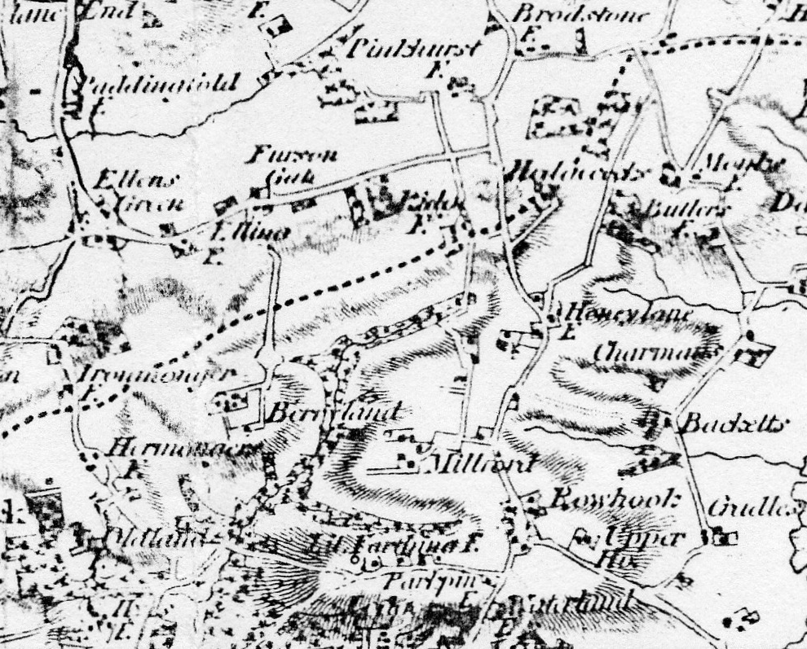
The common linking factor in these and all the farms of Rowhook was a network of tracks, and the turnpikes, which allowed them to move about - when the weather allowed. These tracks included Honey Lane, once an alternative coaching route from Dorking, today a muddy but attractive green lane. Another one led north-south to the west of Horsham Road passing Millfields to Ridge and on into Surrey, parts still another green lane right of way. A third is the various lengths of Stane Street on the parish boundary which still function as paths. The fourth has been described as Rudgwick’s old route to Horsham passing Godleys, Hermongers, Old Land, Parkpin, Farthings, Chequers Inn, thence on the modern road to Slaughterbridge and Broadbridge Heath. This route is crossed by another from Bucks Green, called Bowcroft Lane, passing Hyes to Hermongers and the lane to Ellens Green. Yet another is the Sussex Border Path north of Hermongers, and Bury St Austen’s, passing through Ridge and Hedgecocks. The final one is Monks Lane from Oakwoodhill through Monks where it crosses Stane Street, and on to Butlers in Warnham, thence southwards in that parish. No other part of the parish has such a density of interconnected tracks no longer in use.

Left, 1st Ed OS map of Rowhook

Farms and Holdings
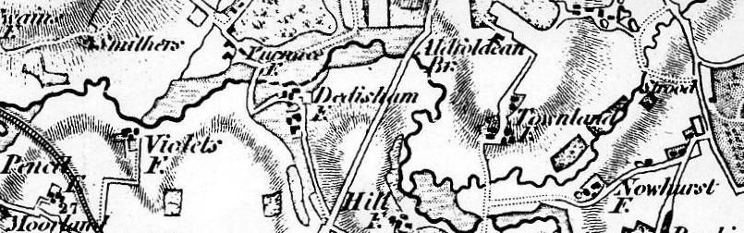
In summarising the land ownership, holdings were complex, and cut across the parish boundaries in Rowhook. They were also in some significant cases part of much larger landed estates. Additionally, many holdings were held copyhold of Dedisham manor: Hermongers/Hitchcocks, Berrylands, Ridge, Blacks, Ockleys, Snell, Millfields, Little Millfields, Stringersland, Chequers, Farthings, Parkpin, Lodge, Furnace, and Townland (Slinfold).

Hermongers with Old Land, Hitchcocks, part of Godleys
In 1812, Col George Wyndham’s father, the Earl of Egremont, owner of the massive Petworth Estate, had obtained 260 acres from the Michells (a junior branch of the old Horsham family), comprising 132 at Hermongers (with Old Land and Hitchcocks), 104 mainly woodland at Godleys, Honeybush, then part of Hedgecocks, 7 at Lemons, Surrey, and a further 24 at Godleys. In 1840, manorial records show that 64 acres at Godleys and Hitchcocks (and an outlying 39 acres of mainly woodland at Honeybush) were sold to Richard Gates in 1840. The remainder approximates to Col Wyndham’s 180 acres farmed in the tithe schedule by William Jelley Sr, aged 75 in 1841, having farmed here since the 1820s. In 1851 his son Wm Jelley Jr stated he farmed the same 180 acres.

Parkpin with Townland (Slinfold)
Jelley also farmed Mary Harmes’s 43 acres at Parkpin, contiguous with the above, which taken together made a respectable farm holding for the Jelleys. Miss Harmes had 422 acres altogether in Rudgwick. A few acres of which was Hilland, part of Townland Farm in Clemsfold (in Slinfold) near Rowhook. She was a wealthy Horsham heiress, but only had a few more years to live. She would have had little interest in separately letting Parkpin, too small a holding.

Hedgecocks with Honeybush and part of Boundstone (Oakwoodhill)
Daniel Mann aged 70 occupied the 25 acre farm holding owned by Richard Gates of Godalming at Hedgecocks, but this farm includes part of Boundstone in Surrey, so he actually had nearly 100. Gates kept the woodland in hand for his timber business.

Honey Lane with Blakes (Rowhook Farm) and others in Warnham
Thomas Barnett owned Honey Lane Farm, 94 acres, and Blakes (Rowhook Farm) opposite the Chequers Inn, 19 acres, with considerably more in Warnham parish, and a further 2 acres opposite Little Millfields. At the sale in 1882, Honey Lane and Rowhook Farms together were 194 acres. The whole estate in the 1840s, mainly in Warnham, amounted to 1000 acres altogether! His father Richard Clemson Barnett was a property owner, not only in Warnham and Rudgwick but also in Buckinghamshire and in Central London, where he himself lived near Cavendish Square. Thomas Barnett lived at West House Farm, now Westbrook Hall off the A29. Barnetts owned Charmans, Betchetts and Cradles Farms (later Rowhook Manor) on the Warnham side of Rowhook, and Endes Place (aka Old House) too. Evidence from both 1841 and 1851 censuses has Daniel Mann’s son James living at Honey Lane farmhouse as an ag lab (and in 1861 at Rowhook Farm), suggesting the two were run as one for many years, although in 1841 the farmer at Rowhook was Reuben Cripps.
Lodge with Furnace House
In 1844, James Fuller farmed 39 acres for the Duke of Norfolk at Lodge Farm. Edward Churchman of Berry House farmed Furnace House, another 126 acres. The rest of the Duke’s land was 160 acres of woodland in hand in Roman Woods (known in the schedule as Furnace Coppices, as these woods had once been fuel for the defunct iron industry. By 1851, W Gravatt farmed 100 acres at Furnace House, after Churchman had moved to Lydling. The Norfolks were lords of Dedisham manor which had most of the farms in Rowhook, but of course there estates at Arundel and other parts of the country were enormous, and, fortunately for Rudgwick, well documented in the archives in Arundel Castle.

Monks with Butlers (Warnham)
Edward Child of Slinfold who owned Upper Hillhouse in the west of Rudgwick and in Slinfold, had 89 acres at Monks, yet William Scragg farmed 140 acres. Scragg also farmed Butlers Farm (now demolished) in Warnham.

Little Millfields with Little Farthings
Little Millfields was just 7 acres. The 30 acres farmed by Joseph Peters, then by James Munday also included Farthings. Little Millfields was owned by the Smallpiece family of Guildford, and 18 acres at Farthings by Edward Child, the owner of Monks.

Millfields with Ockleys
James Bravery, the Dorking miller/farmer had 33 acres at Snell, which he rented from the Arden family, and also owned and farmed in his own name 35 acres at Ockleys. He also owned 100 acres at contiguous Millfields he had bought from Henry Dendy in 1840, which he rented to James Stanford. Dendy set off for Australia to found a colony! The mill was soon to be passed on to James Chandler, whose family had it for many decades.

Berrylands with Pollingfold (Ewhurst), also at Furnace House
At Berrylands (Bury St Austen’s), Edward Churchman lived in Berry House, and farmed 145 acres himself, in the tithe schedule, with a further 31 at neighbouring Pollingfold in Ewhurst, but shortly after he moved to Lydling near Godalming. The Churchman family had been at Berrylands since 1701, and built Berry House in the 1760s. It was all sold in 1851, and J Pullen the tenant in 1851 census farmed the full acreage of 175 acres. Churchman also rented Furnace House 126 acres from the Duke of Norfolk up to 1851.

Stringersland
Sarah Holden owned 51 acres at Stringerland (Chequered Oak House). This holding was surprisingly small, and the house was divided for two labourers’ families. However, the Holdens had other land in Slinfold and owned the inn there, but the Holdens never got to own the Chequers adjacent to this farm. A different Charles Holden owned the farm before and after her.

Rudge (Ridge) with Blacks
George Marshall of Godalming owned 80 acres at Ridge and Blacks, farmed by John Nash. This is the smallest holding to be farmed independently.
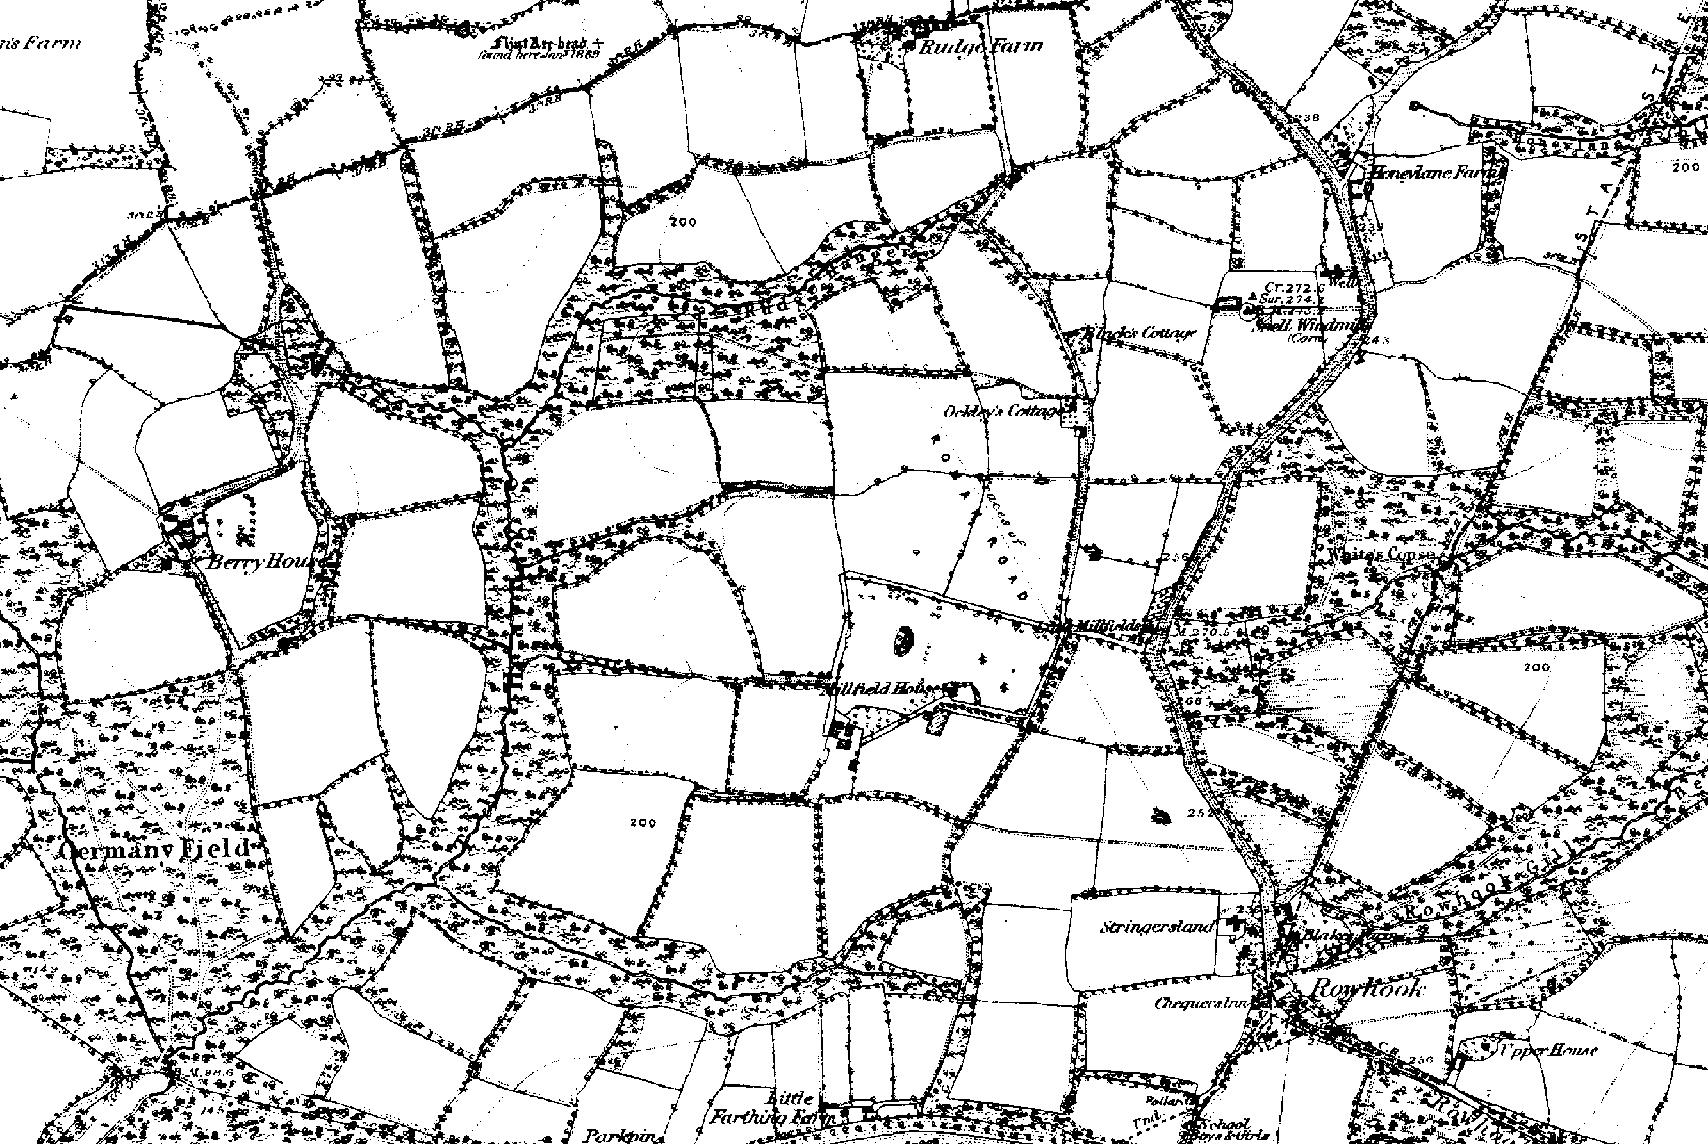
1880 OS map of Rowhook. The line of Stane Street is picked out in the east, with the winding turnpiketo its west, and a third north-south route passing Millfields, Ockleys and Rudge.

