Rudgwick Project 45
This project was born of the 2025 80th anniversary of the ending of the Second World War. It was also a nod to the hugely successful project we ran from 2014 to 2018 collecting family stories of war service by the families who lived in Rudgwick at the time – service in The Great War (published as Volume 2 of The History of Rudgwick in the Great War, RPS, 2018, available on this website).
I always knew it would be harder to find stories of the Second World War. There are fewer online resources, and they are subject to data protection. Some veterans and indeed many children born at the time are still alive. Whilst this might yield stories, there is not the same feeling that you are writing history.
Those we have collected are therefore the tip of an iceberg. The criteria were to involve anyone who wanted to share their stories, of themselves or their parents, irrespective of whether they lived in Rudgwick in the past, and/or to include memories of the post-war years among those of us who were too young to remember the war itself. Contributors have not received any help; this is entirely in their own words.
If anyone reading this is moved to add their story, please do, by sending it to me, with illustrations, if any, at rjnash@weyhurst.co.uk, any time.
CONTENTS
Doug Betts 2
Bob Burse 3
Bety Clark 5
Ean Clarke 7
David Luget 9
Joyce Muir 9
Mike & Vera Clarke 12
Peggy Clay 13
Richard Davies 14
Roger Nash 14
Tony Coles 20
Vanessa Lowndes 22
Judy Buckley 23
Pat Davidson 26

Doug Betts, Summerfold
3 September 1939, written by my sister Sylvia Betts
I am 4 years and nearly eight months old. Just a week or two ago the whole family were having what looks, from the snapshots, to be a carefree summer holiday in Bournemouth – Mum, Dad, Nanny, Grandad, Uncle Will and his girlfriend (my Godmother) Phyl. But, they are very aware of all the convoys of army lorries rumbling by and what that meant. Now I was sitting on the floor of our living-room, in the topmost room of the 1900 house in Niton Street, Fulham. There is an excellent view from the window of all the adjoining long gardens, neatly kept and in their summer beauty. It may not be far from the centre of London but there are many trees, bushes and flowers. There is a large Vicarage garden to the right belonging to St. Clements Church. You can see the back of the houses in Crabtree Lane. They have much less garden.
I had been given new hand-knitted white socks, but I was struggling to pull them on. They had been cast off too tightly. I was wearing a new white fine lawn dress with little satin rosebuds woven into the cloth, a very full flouncy skirt finished off with a sash ending with a large bow at the back. Mum was a wonderful dressmaker and would run up a beautiful dress for just shillings using her expertise on the old treadle Singer sewing machine. The radio is playing on the sideboard, and a voice is droning on. It is a man and he sounds very serious. Stupid socks! Then I cannot get the button on the strap of my shoe to go through the button hole. I look round hoping for help but Mum and Dad are sat close to the radio listening to every word. Mum started to cry. Dad tells her not to be so stupid. Then an ear-piercing wail breaks the tranquillity of a Sunday morning. Dad snatched me up, leaving my sandals behind despite my protest. He carried me down the first long flight of stairs, the small one, another long one and another short one. Through the passage into Nan’s living room and through the French window. It is to become a familiar journey. The garden is 200 yards long. Round the cherry tree, down the path past the gypsophila, the red and yellow gaillardias, the loganberries ripe on their canes, past the vegetable plot, Grandad’s pride and joy, and at last we reach the Anderson shelter sited between the trees, Bramley, Cox and the Williams Pear. We all tumble in. Down into the dark interior, someone lights the nightlights sitting on china saucers. Then neighbours, Mr & Mrs. Whenman, who had decided not to have a shelter, are there begging to be let in. I leant back against the back of the shelter and Mum started to fuss because there is black grease on the back of my lovely new dress.
Families earning less than £250 a year were issued with Anderson shelters free; others earning more had to buy their shelters for £7.00. A hole had to be dug 7’6” long by 6ft. wide to a depth of 4ft. The 6ft. panels bolted at the top to form an arch were then planted into the ground. The shelters were 6ft. high in the middle so most people could stand up, and the standard length of 6ft.6” allowed two people to lie down in comfort. The shelters were intended to accommodate six people sitting or standing. During the September to November 1940 blitz, when London was bombed for 57 consecutive nights, most people retired to their shelters after dusk and there they stayed till the following morning. Imagine a kingsize double bed 6ft.6” long by 6ft. wide and you have some idea of the space they all had to share. Dad and Will with some help from Grandad erected the shelter, and most neighbours helped those less able. Dad had already erected an Anderson shelter in our little garden at our house in Greenford, but because of the clay soil it kept filling with water and this together with the large factory at the end of road, Glaxo Laboratories, were acceptable excuses for Mum to want to go back to the house in Niton Street. Two or three times a week she would take me on the train back to Fulham....Dad did a good job in the shelter, fixing up sleeping benches either side with shallow bunk beds above. Eventually the “all clear” sounded, and everyone clambered out relieved that this is just a false alarm.
This is followed by a hasty packing of suitcases and picnic baskets and soon we are off, Mum, Dad, me, Nana and Grandad to Little Cornard, near Sudbury in Suffolk, to stay with Mrs Cousins. We were running away, but we were not quite sure what we were running from. Mrs Cousins is an old friend who had been in service as a cook with Aunty Edie my Nan’s sister. She had married late in life to a butler and retired to this delightful cottage with a large productive garden. Before he died they had built on a modern extension of living, dining and bedroom but there was no bathroom, no kitchen, no main drainage and no electricity. Mrs Cousins had grey curly hair and red shiny rosy cheeks, and looked delighted to see us all. Alongside are a terrace of tied cottages and other children to play with that I am glad to see again, especially Doreen whose Dad works at the Sawmill. Mrs.Cousins sorts us out some bed spaces including one behind a curtain on a landing. There are chamber pots and washstands with basins and jugs. The privy is down the garden and Mrs. Cousins rustles up wonderful meals in a brick built kitchen in the garden with a Calor stove. However, after a few days with no sign of sudden invasion we return to Fulham.

Bob Burse, Woodfield Road

Allen Henry Burse - Army History

Allen Burse served 1919-1925, and 1939-1946.

19/09/19 Enlisted at Chichester: Royal Regiment of Artillery on a Short Service Engagement
20/09/1919 – Posted to No.4 depot at Woolwich - Royal Field Artillery
26/09/19 – Posted to 4th A Reserve Brigade – Seaford
29/10/19 – Posted to 23/24 Bridge
01/07/21 – Posted to C Squadron 4th Regiment
01/02/22 – Posted to 23/34 Brigade
06/05/22 – Posted to 66/4 Brigade
09/03/25 – Appointed Signalman
18/09/25 – Transferred to Army Reserve

It seems likely that from 1930, he had employment with CC Naumann Esq at Aliblasters, Rudgwick, living at first on Redhouse Hill, Bucks Green, then from 1935-7 in a staff cottage at Alablasters. The Naumanns moved to Campden House, Chipping Camden in 1937. Allen Burse and his family moved to Groom’s Cottage, near the house. In the September 1939 Register both families are shown living at Chipping Camden and Allen’s job was a Groom/Chauffeur, just prior to his return to the army.

1939, Second World War Army Service for Allen Burse
Army Reservist, mobilised on 4th October 1939, posted to reception centre
Posted to 12th Anti-Aircraft Brigade 12th October 1939

Overseas Service, British Expeditionary Force, France 13th October 1939 to 19th June 1940.
The BEF began moving to France on 4 September 1939. The BEF assembled along the Belgian–French border. The BEF took their post to the left of the French First Army under the command of the French 1st Army Group (1re groupe d'armées) of the North-Eastern Front (Front du Nord-est). Most of the BEF spent the 3 September 1939 to 9 May 1940 digging field defences on the border. When the Battle of France (Fall Gelb) began on 10 May 1940, the BEF constituted 10% of the Allied forces on the Western Front.

The BEF participated in the Dyle Plan, a rapid advance into Belgium to the line of the Dyle River, but the 1st Army Group had to retreat rapidly through Belgium and north-western France, after the German breakthrough further south at the Battle of Sedan (12–15 May). A local counter-attack at the Battle of Arras (21 May) was a considerable tactical success but the BEF, French and Belgian forces north of the Somme River retreated to Dunkirk on the French North Sea coast soon after, British and French troops being evacuated in Operation Dynamo (26 May – 4 June) to England after the capitulation of the Belgian army.

Middle East Force, 4th February 1941 to 27th April 1944
Appointed paid acting Lance Bombardier 2nd February 1942
Reverts to rank of unpaid Lance Bombardier 3rd January 1943
Posted to P light battery 20th March 1943
Appointed paid acting Lance Bombardier 12th April 1943
Redesignated to 463 light battery 15th April 1943
Granted rank of Bombardier 21st June 1943
Posted to 85 field regiment 18th October 1943
Posted to 95 Anti-Tank Regiment 20th November 1943.

British North Africa force 28th April 1944 to 26th June 1945
Posted to general headquarters 18th April 1944
Released to Army Reserve 14th November 1945
This cause of discharge was due to him attaining the age of 45 with no further liability for
recall, from 5th January 1946. Alan now out of the army for the second time.

When Charles Naumann died in 1946, his widow Helen moved back to Rudgwick, this time to Rudgwick Grange. Staff moved back too, including the Burses. He and his wife Charlotte lived at Rose Cottage, then at Rolls Cottages, The Grange, until about 1953. I believe his job at Rudgwick Grange, near Tisman’s Common, was also as chauffeur.

Elizabeth (Betty) Butcher, now Clark, High View Villas, Tisman’s Common
1942-1945, 3, Lawns Cottages, Baynards
I was born in April 1942. I never knew my father. I describe myself as a war baby. My earliest memories are of VE Day, sports held in Stanley’s Field at Baynards. All the children were given 10/- by the owner of Baynards Park. My only other memory of the war years (apart from home life) was seeing a Red Cross train in Guildford Station.
I lived with my grandparents at 3 Lawns Cottages, Baynards. There are 13 terraced cottages in the row. Back then, there was no running water or electricity, and the toilet was out the back of the house. Downstairs were three rooms, scullery, kitchen and sitting room, upstairs three bedrooms, two doubles and a single. Six adults and me, a baby, squeezed in. Also there were evacuees, the only ones I remember were a mother and two daughters. I knew the mother as Aunty Dink! The girls were Joan and June Matthews. Their father who stayed in London, and worked at Woolwich Arsenal, was Stan. I was still in touch with Joan until very recently. It may be she has passed away.
Roger Nash adds: in the 1939 Register, Betty’s grandparents were host to another family Edith Stow (whose husband was Edward Stow, living in Streatham, a wharf gatekeeper) and her two boys, Edward (1929) and Frank (1932). The little house housed 12 people, no less than four children (other than Betty) redacted!
My mother worked at Collins Farm on the Baynards estate, where there were prisoners of war working. She was friendly with them which must have been appreciated as they made her a sewing desk, and a dolls’ house for me. I still have the desk.
To help eke out the rations, my grandad had an allotment where he grew mainly potatoes and onions. He also had ferrets which he used to catch rabbits for the pot. Grandma would skin them, and the pelts were collected to send on for clothing.
My grandma kept chicken, ducks, and geese, also a pig at the bottom of the garden. When the pig went to slaughter, the Ministry of Food had half and we had the rest.
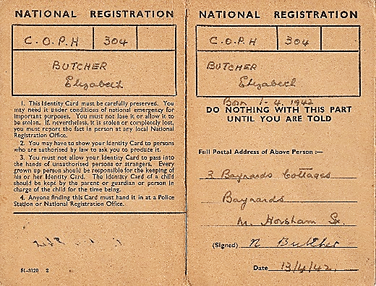
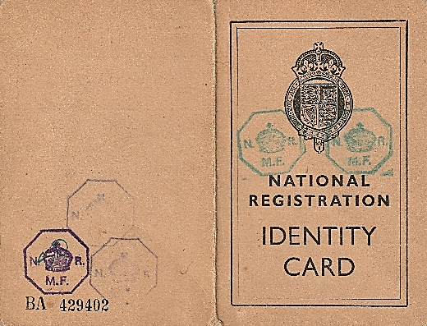

Betty’s Identity Card

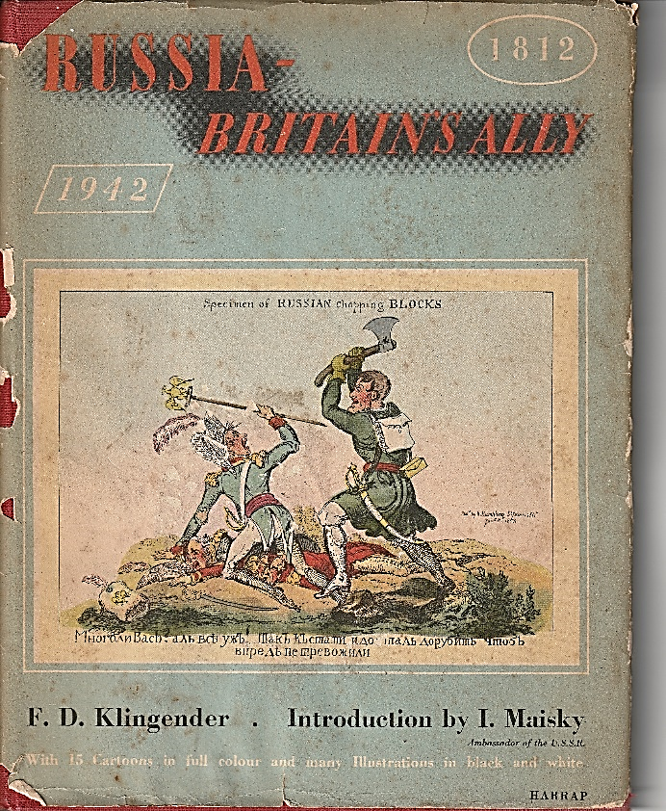
Betty has this book, dating from 1942, when Russia (USSR) became our ally against the Axis Powers. The comparison is with 1812, when Russia and Bretain were allied against Napoleon’s France. The book is a collection of Georgian and mid-20th century cartoons.
The spiral bound book below was published by
the Daily Mirror in 1949, another of
Betty’s keepsakes. In it were a wealth of cartoon style coloured recipes of Patsy’s Reflections. At the time, there were thousands of new housewives cooking for new husbands after the war. A unique take on the time. The back cover
has a contemporary advertisement.

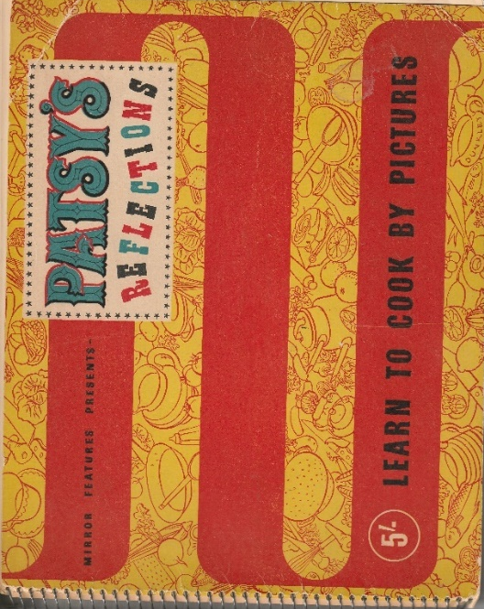

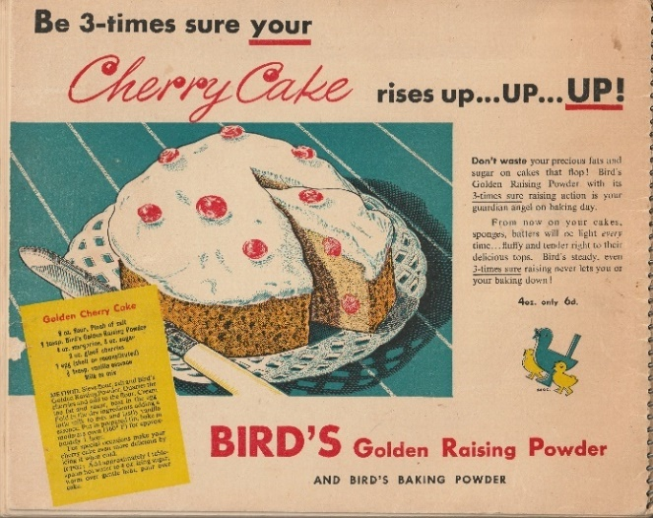

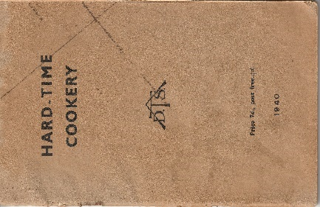
From Thrifty to Hard-Time to Win-the-War, which was the best title? Which the most optimistic? Which the most hectoring? Which the most likely to sell? Note that the middle one was from the Association of Teachers of Domestic Subjects, the one on the left from The Ministry of Food, the one on the right from Mother and Home Magazine.
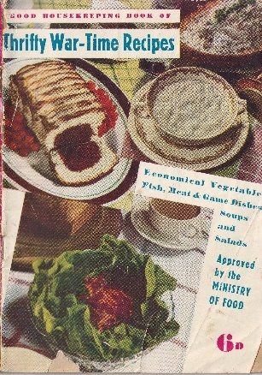
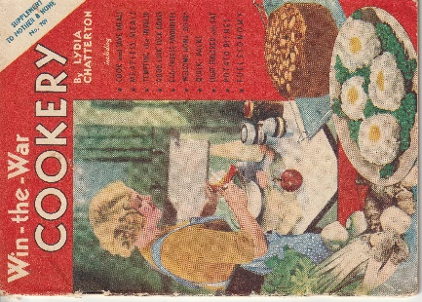

Ean Clark, High View Villas, Tisman’s Common
Chauffeur in two world wars (compiled from research by Roger Nash, using Charles’s 1941 diary, in possession of Ean, his grandson)

Charles Ernest Wickenden had been a groom, later chauffeur, in some grand households, at Welbeck Abbey for the Duke of Portland, his driving license numbered 10 in Nottinghamshire in 1904, then for Sir Charles Ellis at Rampton Hall. He had even driven Sir Charles on the Continent, and served in the Great War in The Sherwood Foresters. In the 1920s he spent time with the Sir Charles at Malquoits, Ewhurst, close to Rudgwick. Then he transferred with the family to Rotherfield Hall, E Sussex, in 1927. By 1939, he was driving for Lady Inez Ellis, still at Rotherfield, who lived there for the rest of her life. Charles was back driving for her after the war, until his retirement in 1948.
In 1941, for which year his diary survives, he was 56. His two sons were serving in the forces, Charles Jr serving in A Coy, 5th Battalion, Royal Sussex regiment as a medical orderly, Wilfrid a driver in the RASC. On 2 January, he drove Lady Ellis to a wedding at Heathfield, but on 9 January he had a telegram, asking him to come to Horsham next day, when his diary says “went by train, got a new job”, which started on 13 January, with a house move too for him and his wife Mabel.
The diary also reveals he was an ARP Warden, and on one occasion went to the Odeon cinema in Horsham for an ARP lecture, on another a “bomb lecture”. and meticulously recorded air raids and “all clears”, probably in connection with his ARP duties. Beds for fire watchers arrived on 22 February. On 6 March there was “blackout trouble”; on 7 March he got a new tin hat! On Saturday 22 March “no alert tonight” was probably noted with relief. This then happened more frequently, though the Blitz did not finally end until May. 16 April was noted as a bad raid on London. On 18 April, Mr & Mrs Wilton came on night watch. Does this suggest that the “work” he was doing was actually with the ARP organisation? As the month’s ticked by, mentions of ARP duties became infrequent.
With respect to work, Over his first few days in Horsham, he names working with Mr Wilton and Mr Oxley, a letter from Mr Shaw, buying large quantities of petrol (a scarce commodity at the time), and helping with “experimental plant” on a number of days. He also continued to buy petrol, He drove a 25hp Wolseley car, presumably for work. He also drove an Austin and took Mr Wolsley’s mother to London in it one day. An indication of why he needed so much fuel and two cars, was his visit to Horley, Redhill, East Grinstead and Haywards Heath, all the same day. He was paid £4 a week, agreed by the month’s end. A Mr Brisley seemed to have the money to spend. On 8 February his work moved office. Tow (sic) wanted the Austin at 10.00 to go to London. Mr & Mrs Tow were referred to another day. He also took Mr Wilton to Exeter, returning the next day by train. On 4 March he drove Mr Sims to Reigate and Dorking, on 6th to Worthing, back by bus. He meticulously recorded small purchases, probably for work. On 19 March he was in the police court, “work for Mr Eager” (a prominent Horsham solicitor). As spring moved into summer, entries got fewer, but the use of the car by him and by other colleagues continued. Mr Brisley (Baisley?) was a more frequent user, and Charles became interested in the mileage reading after use. Charles also seemed to be the person who mowed the lawn at the office. Trips by car to London may have opened his eyes to the damage he had recorded as air raids over Horsham.
On 1 July, he got to go the Park Lane Hotel for dinner and tea, using the car park, to Bond Street, and to the Dorchester Hotel. Two days later he was back, with Dr Fleming to High Holborn, Grosvenor Hotel, Gray’s Inn, Park Lane Hotel, Windsor House in The City, and in one of those had “dinner tea etc”. Similar journeys were undertaken twice more that week, on the Saturday taking Dr Fleming to King’s Cross. The next week he was back into London four times, and again in the third week of July, when a new destination crops up, Iddesleigh House. Again Dr Fleming had to be taken to King’s Cross. Then Saturday, he was house hunting with Mrs Cook and to a tea party with Mr & Mrs Wills. The month ended quietly. Even the office was closed for three days in the first few days of August. On 12 August there was a visit to the Air Ministry. Over the summer there were no air raids, but fuel and oil purchases continued in importance, often several times a week. Car trips were mostly short, the furthest to Worthing. Digging spuds became important mid-August. On 11 September, a new destination appears, to Portsmouth, 122 miles recorded. Ferrying around Mr Mann and Mr Bernard become frequent. In early October there was another flurry of four drives to London in the first week. Many mentions of a garage occur on these visits to London, probably because it had to be paid for. New head light masks probably was because he was no having to drive back in the dark, no mean feat in the blackout. Drives to Worthing were constant, but the end of October saw another flurry of visits to London. Then on 19 November, a drive to London via Kingston and Streatham was foggy, another hazard.
Renewal of his driving license from 28 November cost 5/4½. He had been driving since 1904! Balloons were bought just before Christmas, when he had four days off. Then out to the shops to buy a suit (£8.18.6), cap (17.11), gloves (16/6) overalls (£1.4.6) and boots (1.10.0), befitting a chauffeur.
The back of the diary reveals a few snippets. Mr J Baisley lived in North Heath Lane, Mr TO Wilson (TOW above) lived in Parkfield Road, The Chemical Engineering Company in Horsham had a telephone number, the ARP telephone number was Horsham 1282. Unfortunately neither man lived in Horsham in 1939.

David Luget, Lynwick Street
Run Rabbit Run
A family, living in north London, kept rabbits during the war, probably like many others to supplement their meat ration! One night a nearby bomb blast toppled the hutch and, in the morning, after the husband had gone to work, all the rabbits were seen hopping around in the garden, feasting on the home-grown vegetables! With the help of a neighbour, the wife righted the hutch and set about chasing the rabbits and returning them to the hutch. After a while the neighbour said: “You've got an awful lot of rabbits!” They investigated more closely and discovered that the blast had damaged a panel at the back of the hutch, allowing it to flap, so that as fast as the rabbits were being put in the front of the hutch, they were hopping out the back!
Exeter
Family history researchers looking for Devonshire ancestors are still suffering the consequences of the war even some 80 and more years afterwards. Apparently, some time before the war, genealogical information like church records from across the county of Devonshire was collected ‘for safe keeping' in a central repository in Exeter. After the bombing of Dresden, it is reported that Hitler grabbed a Baedeker guide and targeted some of Britain's most historic cities, one of which was Exeter, which suffered heavy bombing and all the records were destroyed.

Joyce Muir, Freshwoods
Wanford House
More Childhood Memories of World War 2
Joyce has written two pieces for RPS Review on her younger years at Wanford, Autumn 2022, Autumn 2024.
The army camp in Rudgwick was the biggest for miles around. Far bigger than the one at Barns Green and the quite small one in Marringdean Road in Billingshurst. The only rival in size to the one in Rudgwick was at Strood. This took up all the field from Strood Park(now Farlington School) parallel to the A281 as far as the dip opposite Rapkyns. The Rudgwick camp spread out on to the fields on the right of Watts corner right up to the bridge. Then it extended back as far as the dip and stream. So no Princess Roads, no school, no Marts. The whole area covered in Nissan huts.
In the early stages of building the camp in Rudgwick there was no parade ground. So the [Canadian] soldiers practised their drilling on the large forecourt in front of the Queens Head public house. Their marching practice was performed up and down the road in Bucks Green. As a child going to school, I found this very intimidating. Lots of shouting and stamping. Then the boys started imitating the marching whilst going along the pavement to school. Eventually the girls joined in with lots of striding out and arm swinging, All great fun.
I lived down the Haven Road, just over the bridges and up the hill at Wanford House. We had a large garden and initially my mother was asked to provide vegetables for the officers’ mess. But soon more and more vegetables were required. We had two gardeners, old Mr Broadbridge and young Tom. The adjectives seemingly part of their names. Both stayed with us throughout the war. Old Mr Broadbridge did very little but supervised young Tom. I now realise he was not a bright lad but a good worker. He was never called up to be a soldier.
My mother was an avid gardener, more and more vegetables were required and village women were recruited to help enlarge the garden. As it got bigger, gradually extending into the orchards, so did the army of women gardeners. Looking back I now realise my mother was providing a sort of community hub for the women to join. They had to say what hours and days they would be available each week and were paid accordingly. They all worked hard in all weathers as they responded to the call to “Dig for Britain”. But they also had the opportunity to get together and exchange stories and give mutual support. Most had sons, husbands or brothers in the forces, a worrying time for all.
We also kept chickens both for meat and eggs. My mother also had 6 bantams which were free to wander all around the garden. I often sat on a garden bench with Mr Kelday who shared the house with us during the war, with my doggy Nobby sitting at our feet. We watched the bantams hunt for grubs and insects among the plants, The bantams were so amusing with their long feathery trousers. Nobby knew she was not allowed to chase bantams.
As we had bred more and more chickens, as well as their own big run, they had taken over the grass tennis court which did not please me as I liked playing tennis. One day I heard my mother say that they needed to make another run for the chickens as they were too crowded. I decided I had the solution and opened the door of the chicken run. Gradually all the chickens came out and explored the garden. Sampling leaves of different vegetables, even climbing into the apple trees to sample the fruit. They were having a great time until one of the women gardeners called, “the chickens are out!” Everyone came running to chase the chickens which flew about both high and low. Nobby and I joined in. It was the greatest fun. Mr Kelday laughed and laughed. Eventually all the chickens were restored to their runs and I was told I was a very naughty girl. “Alas it is very difficult to help grown-ups sometimes” I decided.
The chickens were culled about once a month. Some going to the army camp and some to my uncles’ London stores along with rabbits all to help extend peoples’ meat rations. Initially my mother’s sisters who lived in the village were called for chicken plucking days. I had an aunt living with grandmother at Hatches in Lynwick Street. Another at Canfields farm further up the road. Then another I knew as Aunty Glaxo(really Gladys) who lived in Little Exfold in Tismans Common. All had been brought up on a farm and thus were proficient at plucking chickens. Gradually they were able to stop coming as they taught the women gardeners to take over the work. Nothing was wasted from the chicken. The feathers useful for pillows and feather mattresses. The insides were much sought after to augment meat rations.
The two small barns were used for chicken plucking as they still had earth floors. The big barn and the stables with concrete floors were taken over by the Ministry of Food for storing reserve rations. Sometimes boxes of tinned food, sometimes boxes of margarine. All carefully locked and recorded and checked monthly.
War was announced on 3rd September 1939, the time of year when autumn is approaching, days are getting shorter and darker. The world seemed to mirror that too. Everyone worried about who would be called up to serve in the forces. The darkness was augmented by the ‘No Lights’ policy. No street lights – though we didn’t have them in the country. Also no lights were permitted to show from buildings. So ‘blackout’ curtains were made to contain lights in rooms. Some people even put strips of paper across windows to prevent flying glass should we be bombed.
We were issued with identity cards. My number was ENFW/10/3. I was always one to sort out puzzles, so I decided E was for Edward, my father’s name. N for Nora, my mother’s name. F obviously for Fincken our surname. W must be for Wanford where we lived. 10 was because we were the 10th family that fitted that criteria. 3 because I was the third in the family. All nonsense except for the 3. Gas masks were supplied and had to accompany us everywhere in their boxes. At school we had lessons on how to put on the masks securely. Ration books too were given to everyone. Those of us who lived in the country were not so badly affected by rationing. We could all grow our own vegetables and fruit. Most people also had chickens for eggs and meat. Rabbits too abounded. But there were coupons for tea and sugar, and for fats and meat. Also for cheese although if you did manual work your cheese ration was augmented. Milk was plentiful from the dairy in the village and cottage cheese was regularly made from sour milk. Coupons for clothing were also issued. These sometimes bartered for food coupons. Petrol was also rationed but with few people having cars that did not make such an impact.
As children in the countryside the war and its implications made less of an impact. We did not see the devastation of bombing, we did not have to leave our homes as evacuees. A few of us had relatives in the forces but war in Europe was a seemingly distant place. I am ashamed to say, thinking back, that watching the ‘dogfights’ of the planes in the ‘Battle of Britain’ going on over our heads was just exciting. That lives were being lost did not occur to us. Young children are so often guarded from harsh realities.
Meanwhile there were new people to meet. Sometimes soldiers from the camp would just come into the garden and sit on a bench and talk. A touch of normality they called it. Ever the chatterbox, I enjoyed this. Soldiers from all walks of life, different nationalities, even different colours came. Towards the end of the war we even had a German prisoner of war to work in the garden. I enjoyed practising my very limited German with him, being surprised to find him just an ordinary family man, not the ogre the media would have us believe, Even so I did notice my mother kept him in the flower garden so as not to offend the women working in the vegetable garden.
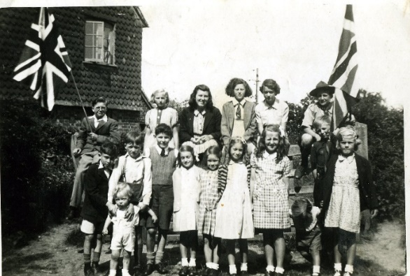
The war ended in May 1945 and initially there was great excitement especially in London. In the village here we had street parties but often life seemed to go on as before. Little glimmers of excitement as individual men from the forces returned home. But we still had rationing and everything was in short supply. The world still seemed grey, it took a while to brighten up.
Children from Haven Road celebrate VE Day, May 1945. Joyce is back row next to the scout.

Mike and Vera Clarke, Bucks Green

Mike goes first

I was born in Portsmouth in 1940 and my parents had a house on the outskirts of the town. I was, of course, a baby when this took place so I cannot verify the facts, but my Mother used to enjoy telling the story, which took place in about 1943. The house, which must have been a military property because my Father was in the Royal Marines as a junior officer, was situated opposite a very large farm field. On the night in question I do recall being taken down the rear garden to a tin shed affair called an Anderson Shelter because of an impending German air raid which duly took place all around us because we were not all that far away from Portsmouth dockyard which was a target. Bombs were dropped all around the vicinity of the house with tremendous explosions.

In the morning when it was all over my parents went to the front of the house to check for any damage and discovered that all of the windows had been blown out and the brickwork was completely pebble-dashed with King Edward potatoes from the farmer’s field opposite. Also a piece of metal was sticking out of the front lawn which my Father tried to pull out, but could not. When it was removed, the piece above ground was about a foot long, but underground it was 3 or 4 feet long and if it had hit the house it would have caused very serious damage.

Vera writes

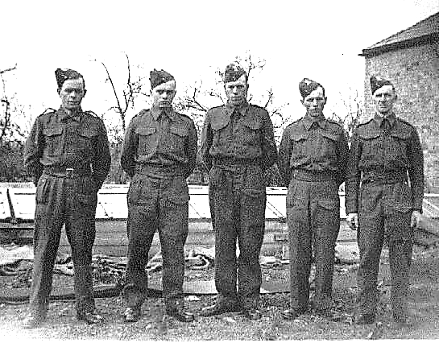
I was a small child born in World War II and the memory I have is of when we lived in Westmarsh, a small village in southeast Kent and not far from Thanet. Being so close to Thanet and the south coast the Germans used to get rid of ammunition as they left our shores, and Dad was very angry one day when they shot through the chain guard of his bicycle. Luckily for him he wasn’t hurt but very cross about his bike. My Father was a member of the Home Guard along with several of my uncles.

Photo Home Guard Westmarsh, Kent – Frank, Alfred, Sidney and Ralph Holden, Uncles and Raymond Beerling (far right) Father of Vera Clarke.
My Mother also had a bad experience when she was walking round the country lanes one day and saw or met someone in German uniform which she reported immediately to the authorities, not sure how, as we didn’t have telephones in those days. However, it was apparently the right thing to have done as it was merely a test to see how observant the locals were and was not really a German.

I also remember Mum telling me that one day when I was in my pram and Mum was working in the fields because my dad was a market gardener, the siren went off and the only thing she could find to cover me was a bushel box used for collecting fruit and vegetables. She put it over me in the pram to protect me and luckily it did.

Peggy Clay, formerly Westlands, Tisman’s Common, now living in Barnstable. Peggy was parish clerk of Rudgwick a few years back
A Lingfield brickworks
I was just five years old at the outbreak of war. We lived at Crowhurst, near Lingfield, Surrey. My father Thomas Pearce was foreman of the Lingfield works of the Sussex and Dorking United Brickworks, and we lived at the entrance to the brick yard in Crowhurst.
At Crowhurst, we were under some of the flight paths from German airfields in northern France to London. We were 30 odd miles from central London, and during the Blitz could see London burning. We were close to gun emplacements and search lights so it was all pretty noisy during raids. Most of the attacks were at night, but not all!
My brother was just five months old, and I was about to start school at Crowhurst CofE Primary School, where my mother was a school manager. There were two teachers and about 30 children. It was a tiny village! But there was a little shop in the front room of a cottage. Mrs Dean sold sweets, cigarettes, and tinned fruit. Mrs Dean had a problem with ration books, cutting out the coupons, as her hands were so shaky.
You had to be registered with the grocer and all goods (or most of them) were rationed. I don’t remember the allowances, but sugar, tea, butter, flour, dried fruit, bacon and meat were all rationed. We were lucky – we had a big garden and were able to grow all the fruit and vegetables we needed, and we kept chickens. Dad shot rabbits. I remember picking strawberries when the air raid siren sounded and we had to run indoors. There was a dog fight overhead, and shrapnel falling everywhere.
We had an underground shelter close to the house. In the Blitz of 1940/41, we spent nights in the shelter, cold and damp. Once, a bomb was dropped nearby. The blast lifted the slates on our roof and afterwards I remember you could see the cobwebs from inside had blown out through the slates. The bomb crater was only a few yards away, a near miss!
Another near miss when I was walking to school, I must have been about 7 or 8 years old. A lone plane after a night raid appeared over the fields, firing. My father rushed up the road, grabbed me, and pushed me into the ditch (good job it was deep and dry) and lay on top of me. We were unscathed. I am lucky and thankful to be here!
The next memorable things to me were the flying bombs, doodlebugs we called them, and the rockets – terrifying! Amidst all this, I sat for the ‘scholarship’ (11+) at the age of nine, and I passed! So in September 1944, I went to Oxted County School, by bike and train.
A German airman said to my father the brickworks would not be bombed as it was used as a navigation aid. My mother gave food to the prisoners of war who worked for them so as a thank you they made her a sewing box.
Richard Davies, Pondfield Rd
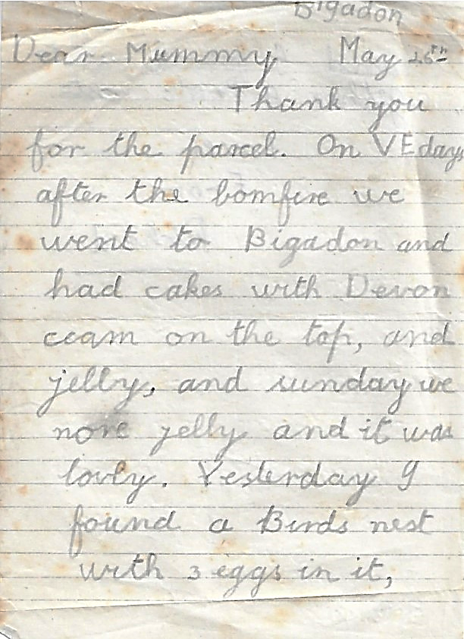
Aged seven in 1944, I was evacuated to my mother’s sister and her family in Totnes Devonshire from Finchley, North London, to escape the flying bombs.
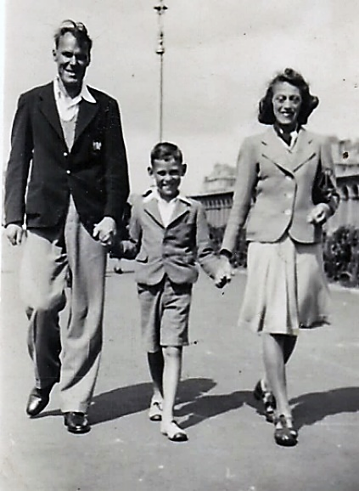
I have an original letter I wrote to parents describing the VE Day celebrations (bonfire and cream tea) at my boarding school [Bigadon House is near Buckfastleigh]. After the war I attended a Thanksgiving Service at Buckfastleigh Abbey near the school.
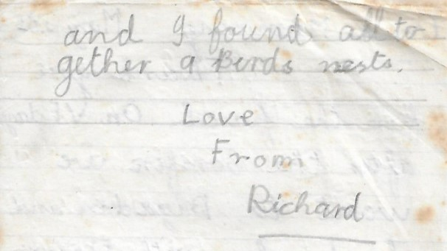
The photo was taken with my parents walking on Brighton sea front on VJ Day, a public holiday if I remember correctly. My parents had themselves earlier moved to Brighton to escape the German V1 and V2 weapons.

Roger Nash, Hornshill Lane, Tisman’s Common
Mum and Dad’s wartime service
My mother, Connie Harris, had started teaching as an Uncertified Teacher in Horsham in 1925. For 20 years, latterly during wartime, she cycled from Loxwood, where her parents had a grocer’s shop, to Rudgwick station to catch the train to Horsham, boarding weekly, back home on Fridays, when she could help out in the shop on busy Saturdays and in the holidays. During the war she stayed with a friend and colleague, Miss Kathleen Woolgar at 7, Greenway.
Her school from 1932 to 1946 was the new Clarence Road Infants School, off Brighton Road (later called St Leonard’s School, before becoming a Teachers’ Professional Centre, but latterly demolished for housing). She taught the youngest pupils in class 1, known as Babies. For this she was paid £144 a year unchanged from 1936, but given a war bonus of £19.10s in 1940, rising to £42 in 1943-4, after which it was dropped altogether. All the staff were female throughout her time there. She did not become a Qualified Teacher until she had done 20 years’ service in 1945, just before her retirement.
The school had one shelter per class made out of brick, partly underground, located on the far side of the playground along the Brighton Road boundary. On occasions when in use, teachers would read the children stories, recite times tables, etc. They were lit by hurricane lamps, and there were frequent practices.
As far as Empire Day is concerned, everyone seems to agree it was a special feature of the Clarence Road School year, even during the war years, celebrated on May 24th, which just happened to be my mother’s birthday, This was a war fought not just by the British, but by Empire troops from all over the world.
The headmistress throughout her time there was Miss Agnes Childs. The school log book, which she was bound to write, reveals a few snippets:
- absence 27 March 1935, death of her father;
- 19-30 August 1940, on holiday (which may coincide with her fiancé, Jim Nash, having leave from his training in Kent, which had begun when he was called up in March);
- absence, 17 to 22 July 1942, “her fiancé being on embarkation leave” (his journey to Liverpool docks began on 24 August);
- on 5 May 1944, Connie had had a fall in the playground which was bad enough to send her to a specialist in London;
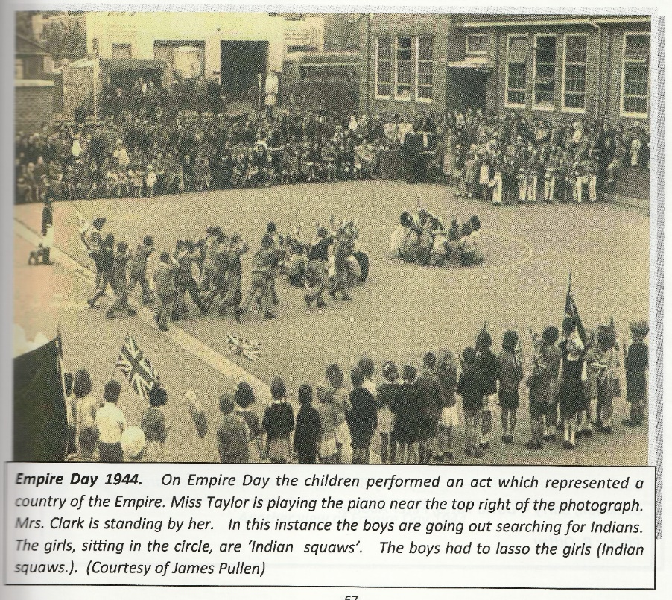
- from 17 September to 11 October 1945, she had leave of absence to be married (24th September, when Miss Childs and Mrs Fry were given leave to attend the wedding, “with a slight alteration to the timetable this afternoon”);
- now referred to as Mrs Nash, on 29 November to 3 December 1945, and 7 to 11 February 1946, she had unprecedented absences for firstly a chill, secondly, influenza (both whilst pregnant with me!).
On her retirement on 30 April 1946, Miss Childs wrote a nice testimonial, which my mother kept for the rest of her life.
“Mrs Nash has taught with me for many years, and has proved an excellent teacher and loyal colleague. Her friendly, sympathetic manner, earned for her the appreciation of the children and the esteem of the parents. She was always keen in keeping herself up to date in teaching methods, and introduced many useful pieces of apparatus. The staff will miss her cheery smile, but we realise that her husband and child claim the first place in her life. We all wish her every happiness in the future. A. C. Childs M.R.S.T. (Head Teacher)”
I was born that June, like so many others, a child of the post-war “baby bulge”, nowadays inexplicably combined with others up to 1964, as “baby boomers”!
Connie Harris and Jim Nash had married 24 September 1945 at Loxwood church. Jim had travelled from near Trieste, Italy, on leave, arriving the day before. They were able to squeeze in a honeymoon in St Agnes during the all too brief period before he had to return to Italy.
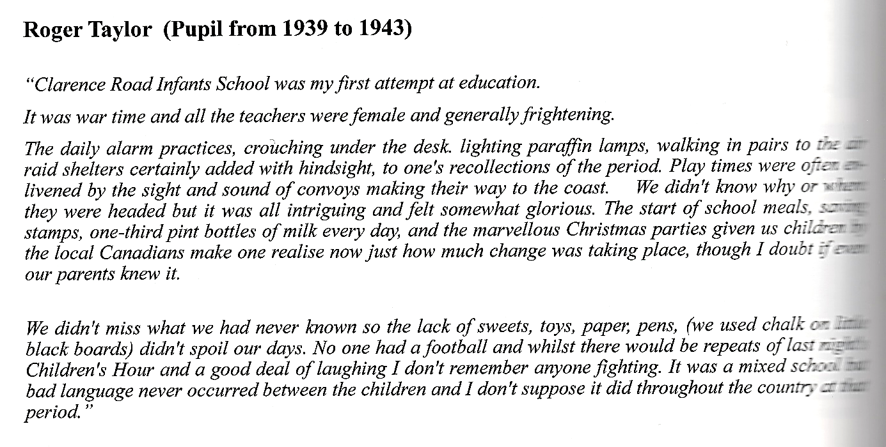
The memories below are from a book called The Way to School, 2015, by Nick and Angela Sexton, both retired teachers known to me, and who in turn had information from me contributing to their book. I like Roger Taylor’s perceptive contribution:
My father, Jim Nash was baptised Eric, but nobody ever called him that his whole life. His war started with conscription. He was a lot younger than my mother, and came of age, at 21, in 1937, so could have been called up at any time, but in his case the call came on 15 March 1940. I do not know when he and my mum got engaged, but it is a fact they were engaged throughout his war service, for at least 5½ years. Some decided to wed quickly when war broke out (as my in-laws did), some when their fiancé was on leave before overseas service, others waited, and wondered if it could ever happen. Anxious years. They had met in Loxwood, when my grandmother Nash had been widowed, and moved there from Warnham, where my grandfather had a farm tenancy which could only be passed on to a son over 21. They were evicted. A brother lived in Loxwood, so he helped them out.
From running a small chicken flock for pocket money, and working in a village bakery, Dad reported to Stoughton Barracks to be enlisted in 2/7th Battalion, Queen’s Royal Regiment (West Surrey). The battalion was sent to Faversham Kent for training, Dad was soon seen as a likely driver, as unlike most of the recruits, many from London, he had learnt to drive on the farm. This meant he joined the HQ Company, which may have saved his life in the campaigns to come, but it tested his resilience beyond measure. From February 1941, 2/7th Queen’s were on coastal defence against invasion; in October they moved to Ipswich, more training. In August 1941, the time came to go overseas, by ship from Liverpool, via Freetown and Cape Town. Here, the drivers (the ‘MT party’) joined a different ship bound for Suez (the canal had been closed, in Axis hands, until after El Alamein), whilst the rest headed for Iraq. Dad always told how he taught the others to drive on the deck of the ship in stationary trucks! At Suez, now in British control, they picked up a fleet of trucks and stores, and headed for Kirkuk in Kurdistan, a first test of resilience, arriving 24 November 1942. That is where he stayed until March 1943, training in the desert, guarding everything that could be moved from clever thieving locals (this strongly confirmed in the battalion history, by Roy Bullen). Winter in Kurdistan is not hot.
There followed what Bullen calls The Longest Approach March in Military History. Dad and the rest of the MT party had to drive the trucks all the way back to Egypt, and then some: destination Tunisia, averaging some 150 miles a day, not actually knowing the destination. From 23 March 1943 they headed west, crossing Palestine, the Sinai, through Cairo, through the El Alamein battlefield, Cyrenaica and Tobruk and Benghazi (Libya), entering Tunisia on day 27. At Enfidaville, on day 31, they were made part of 8th Army, and were fighting the Germans the very next day, 27 April. Google reckons this route can be driven in 55 hours! Dad never repaired another vehicle after the war!
The irony of all this is that by 13 May, the Germans capitulated. 2/7th had though been battle hardened in readiness for much worse to come. Some respite was to be found in Sousse, where swimming in the Med was possible. Training resumed in June, including the use of landing craft for the forthcoming Italian Campaign. The battalion, part of 56th London Division (the Black Cats), was transferred to command of the US 5th Army. Italy capitulated on D-1. A walkover ahead? No way, the Germans were rapidly building up defences in Italy, Nevertheless the Salerno landings on 9 September were successful, Though as a truck driver, there would be numerous times ahead when trucks were the wrong method of transport, and it’s not entirely clear what he actually did, but he was not in a rifle company, so to an extent was protected from the worst encounters with the enemy. By October, the battalion were well north of Naples at Montanaro, and my father’s unit was pulled back to rest for a second time. Ahead lay the “Gustav Line”, formidable mountain defences such as those on 3,000ft Monte Camino, and atrocious weather, taking the heights with great loss by Christmas. Wikipedia: "fought for some of the most miserable terrain on planet Earth in" almost a "trench-warfare stalemate" more alike to that suffered a generation before on the Western Front during the First World War.”
On 21 February, they were pulled back to Naples and redeployed by sea to Anzio where the US army was in peril, and witnessed the sinking of HMS Penelope in which a Rudgwick sailor lost his life. Two invasions of Italy was not good, as Jim often lamented. The battalion was close to being wiped out with many captured (down to one company and a skeleton HQ), as they gave the rearguard a chance to consolidate. Relief came on 10 March, back to Naples by sea. They then had leave, and training, and reinforcements, back in Egypt, opportunities to visit Cairo, a year since they were last there.
On 17 July, they were back in Italy, receiving new trucks in Rome, reverting to the 8th Army again, off to Perugia, but yet more fighting on the “Gothic Line” ensued on 26 August 1944. Through September fighting was fierce, taking such places as Gemmano. Big losses but German prisoners taken. It was hard to follow up the advantage with depleted numbers. Next objective was Ceriano Ridge, truly difficult, supplies only possible by mule, numbers so depleted whole battalions were being merged. But on 25 September, 2/7th crossed the Rubicon (now named Uso). 2/7th were withdrawn south to Macerata until late November.
The winter had finally quietened the front, and a withdrawal for Christmas was possible. One more river had to be taken in January 1945 before the Po Plain opened up ahead. Snow, mud, and freezing weather had to be endured. It was 3 March before 2/7th took the vital bridge. Next, the lagoons of Lake Comacchio had to be taken, the so called “Argenta Gap”. “Operation Grapeshot” was upon them in April, the final assault to win the campaign. Dry land was in short supply, and there were minefields, but German prisoners were coming in. the pace was quickening. By the end of April, the German army was ceasing to function well, spirits were high among my dad’s comrades. The Po was crossed on 25 April, 2/7th among the first across. On 29th they received the surrender of an entire German Engineers battalion. It was off to Venice, and a chance to sleep in a hotel bed! The Germans in Italy surrendered on 2 May. There was just one more problem to solve, the demarcation line (“Morgan Line”) between Italy and Yugoslavia near Trieste, and Dad’s battalion had to do their bit, but this was not fighting, just holding the line and enthusing the local population for Italy. In the event, some of the villages Dad was in would be ceded to Yugoslavia (modern Slovenia). It was at this point he had leave to go home by train across Europe for England and marriage, but not before he had some time to explore Trieste, and swim in the Adriatic. Back in Italy, October was easy, but must have seemed unfair to have to endure the start of yet another winter. I do not know his date of demobilisation, probably before Christmas, after which 2/7th Queen’s ceased to exist.
References
The Way to School, Nick and Angela Sexton, 2015
History of the 2/7th Battalion, The Queen’s Royal Regiment, 1939-1946, Roy Bullen, 1958.

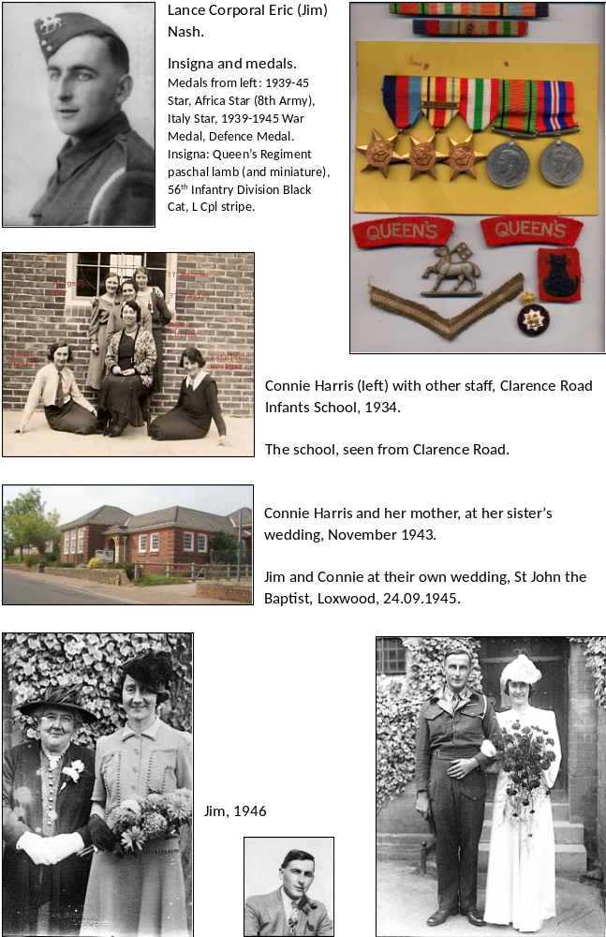
Tony Coles, Cox Green
1945 and thereafter
I was born in September 1944 so the War was still raging but clearly the end was in sight. My parents had bought a house in Edgware in Middlesex when they married in 1937, the first in both their families to do so in what was regarded as a very brave step. They lived there throughout the War, indeed until the early 1950s, but by the time I was born my father was in the Army and away from home. He had been in a reserved occupation (food distribution - he worked in the Borough Wholesale Fruit and Vegetable Market near London Bridge) and to start with was an Auxiliary Policeman. But clearly, with his relatives, friends and contemporaries joining up, he felt he wasn’t doing his bit so joined the Army despite his exemption. Indeed, he ended up at the end of the War as a Quartermaster Sergeant - not bad for a civilian.
Because of the V1 and V2 bombs my mother was evacuated for her confinement and I was actually born in Witney in Oxfordshire, returning home to Edgware soon after.
When father joined up, my mother returned to work in the same company in the City of London, where she had worked before getting married (remember in those days it was usual for women to give up work on marriage especially if, as my parents obviously did, they aspired to be middle class). Returning to work in the City meant a long and difficult commute every day and the fear that on arrival in the City she would be greeted by a bomb site where her office had been. But she persevered. With father away, my mother‘s mother left her own home in Tufnell Park, itself near to Euston station and well within the Blitz zone, to keep house in Edgware while mother commuted and worked.
I always thought that, as my parents were getting older and my mother was becoming old for a first pregnancy, father’s Christmas leave in 1943, with the War going the “right way”, led to my birth in September 1944. But obviously, I never discussed this with them.
Indeed we spoke very little about the War. It seemed to have been a fact of life which everybody had got through, although some better than others. Father was lucky and was never sent abroad and spent his war service in various places here in England.
When VE Day came in May 1945, there was a street party. I claim to remember being there in my pram, but this is obviously nonsense as I would have been far too young. What I’m remembering are photographs of me in my pram at the party. Quite how anybody managed to still have a camera, let alone film, and let alone having it processed, after all those years of War, is interesting. We think now that everything was dreadful, as it must have been, especially in the middle of the Blitz, but clearly life went on.
Indeed growing up, I’ve no memory of being hungry or unhappy or particularly cold despite living through the dreadful winter of 1947 in a house which, although newly built before the War, obviously had no central heating and relied upon what was an irregular supply of poor quality coal for an open fire.
Rationing was a fact of life to me as a young child and, unlike my parents and their generation, was simply normal. That there were no sweets didn’t matter because I had never had any. But upon father’s return from the Army and his reengagement in food distribution there was always fresh vegetables and occasionally fruit. I do remember the first time he brought home a few bananas from the wholesale market.
In 1949, at the age of five, I started primary school. It was, as I recall, quite a long walk from home but I’ve no memory of my mother accompanying me (she’d given up work on my birth and never returned to it) so I obviously just walked on my own, no doubt meeting school chums on the way. Very different from the precautions taken these days, but then there was virtually no traffic and only an occasional bicycle. The nearest bus stop was also a very long walk from home. Playing in the street was never a problem.
I remember the late King dying in 1952. I was very unhappy because it was half term and my mother was to take me to the Science Museum and it was likely to be closed, along with all other shops and businesses as the country went into mourning. I also remember the late Queen’s Coronation because, although my parents didn’t have a car or any proper heating for the house, they had somehow acquired a very small and rudimentary television set which many neighbours came to sit round for the day. I subsequently discovered that it had been given to my father by one of his new bosses; he had moved companies for a better position after his return from the Army and clearly was well regarded.
Soon after, a small car was acquired. It was very second-hand, had a canvas roof which leaked and a small engine which managed about 40mph on a good day. But it enabled my parents to travel to Purley in Surrey to look for a house. This was because I was suffering from asthma and, in those days, the best treatment was said to be living on the high chalk of the North Downs rather than the damp clay of Edgware in Middlesex. It was from Purley that I moved to Cranleigh when I first married in 1969 after an excellent State education (I managed to pass the 11+ at the second attempt!) and professional qualification.
Looking back I now realise how much my parents sacrificed during the War how much they appreciated life as things gradually got better in the late 1940s, the 1950s and, especially, the 1960s. Not only was there more food, heat and home comforts as things like a fridge and a very rudimentary washing machine arrived but wider travelling became possible and the annual two week holiday (that was all there ever was until well into my adult life) was spent in a boarding house rather than the back room of a relative or with somebody letting out spare rooms a long walk from the beach.
As I said, my parents and grandmothers (both my grandfathers had died before the War so I never knew them) spoke very little about life during the War and the sacrifices they made. I think they felt themselves lucky to have come through it unscathed, unlike close relatives who had clearly suffered as a result of military service. I had an uncle who had gone to the Army as a fit young sportsman but came back after serving in the Far East as a broken man who died very early in his middle age. But at least he had come back and had never been a prisoner of the Japanese. So everything was regarded as relevant, and a fact of life.
I never heard my parents speak particularly ill of the Germans or the Japanese so perhaps they regarded them as part of a history from which Britain had emerged victorious. I was certainly taught both at home and at school that Britain was the top nation in the world and London was the biggest and best city - albeit a very sad one with all the bomb sites, many still there when I started my own professional career in the City in 1964. It wasn’t until the Suez War in 1956 and the gradual loss of the Empire that we realised Britain was no longer “Top Dog”.

Vanessa Lowndes, Milford, formerly of Lynwick Street
Vanessa is RPS President
Borneo 1942
In 1942, British administration on the west coast of Borneo, including Brunei, Sarawak, and North Borneo, was disrupted by the Japanese occupation. The Japanese invaded in 1941 and established military administrations, replacing British residents with Japanese officials. The British were unable to fully retake the area until 1945.
Here's a more detailed breakdown:
- Japanese Invasion: In late 1941 and early 1942, Japanese forces invaded and occupied Borneo, including the areas of Brunei, Sarawak, and North Borneo.
- Disruption of British Rule: The Japanese occupation resulted in the displacement and removal of British officials, including the Resident in Brunei, a key administrative role.
- Military Administration: The Japanese established a military administration, replacing British rule with Japanese control.
- Consequences of Occupation: The occupation led to various hardships for the local population, including conscription, economic disruption, and food shortages.
- Re-establishment of British Rule: After the end of World War II, the British regained control of Borneo in 1945.
Following that introduction above from Google AI, the story below is from Vanessa herself.
My knowledge and memories are few and sketchy. My Aunt and Uncle rarely spoke of their internment by the Japanese when they invaded Borneo at the beginning of 1942. My Uncle Dick was The British Resident, West Coast for The Colonial Office. The Japanese did their best to humiliate their captives and Dick was placed, naked, on the prow of the first Japanese landing launch to be shot first in case they were shot at.
Dick talked about the British Soldiers, captured and imprisoned having spent little time in Borneo and unable to cope with the climate let alone imprisonment. Many died of heat stroke.
Dick and my Aunt Benita were apart from each other for the entire time of their captivity not knowing if either was alive. I know from a book written by an American, Agnes Keith, about her internment that she met Benita briefly. I quote from her book, my aunt was known as ‘ ‘the Wonder Child’, she could be lovely, charming and gracious, with a clear thinking, quick, critical mind but made it hard for her to be patient with bumbling ideas or people’! She was an ardent garbage collector throughout camp years and a marvellous cook. Somehow she wangled scraps away from pigs, poultry and Japs; grew a few greens and leeks herself; raised a few giant African snails; tossed them all together over an open fire with a culinarian hand, and out came a meal.’ My father told me that Benita made wonderful Malaysian curries on her return home! This is all I know of Benita’s internment.
Their camps were liberated by the Australian Army in 1945. Dick told me that the soldiers asked them which guards they would like killed? But his reply was that there had been too much killing already. They spent six months recovering in Australia until well enough to return home. Their remaining years were spent farming in Devon. They never looked back and there was no bitterness.

Judy Buckley, Tisman’s Common
My mother Nancy’s life story, an artist who joined the WAAF
The story is extracted from the eulogy at her funeral, with thanks to Judy for allowing it to be published here.
Roger Nash writes: Nan’s father, Judy’s grandfather, was featured in Rudgwick’s Great War, Volume 2, RPS, 2018. George Friend, who was awarded OBE, was a noted engraver, who in The Great War was employed in the Labour Corps as a draughtsman, engraving work in support of the army’s activities. After the war he continued in business as an engraver. He was responsible for engraving the wording on the Sword of Stalingrad presented by Churchill to Stalin at the Tehran Conference in 1943. A collection of his work is in the V & A.
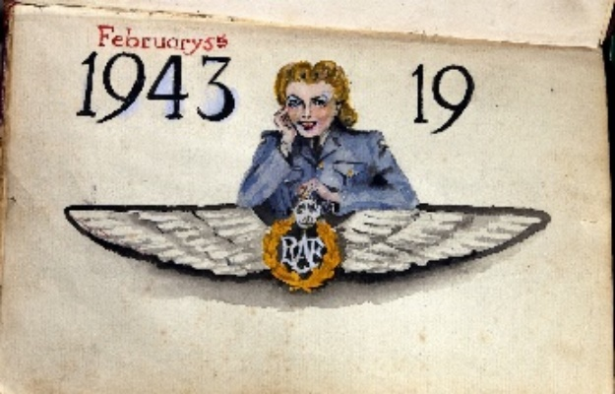
An introduction to Nan’s work: here, a reinterpretation of the Women’s Auxilliary Air Force (the WAAF), curiously unfinished.
All images ©David Buckley

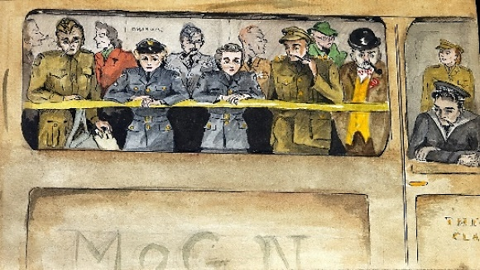
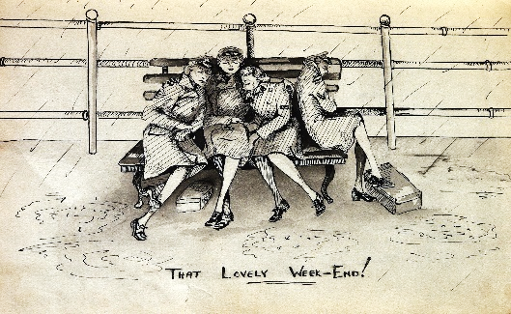
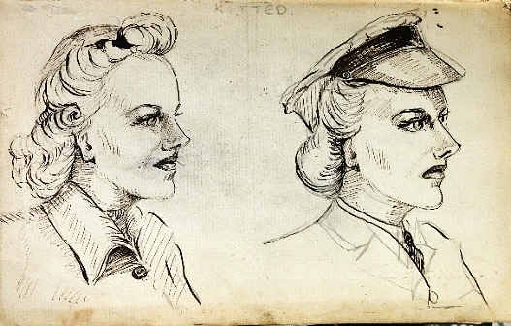
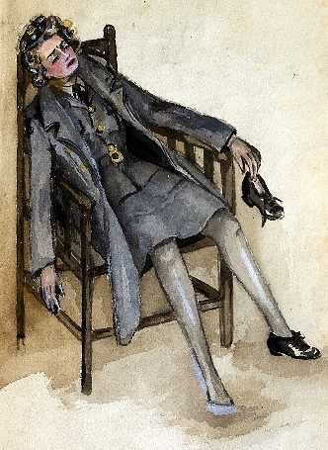
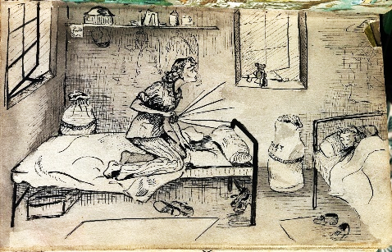
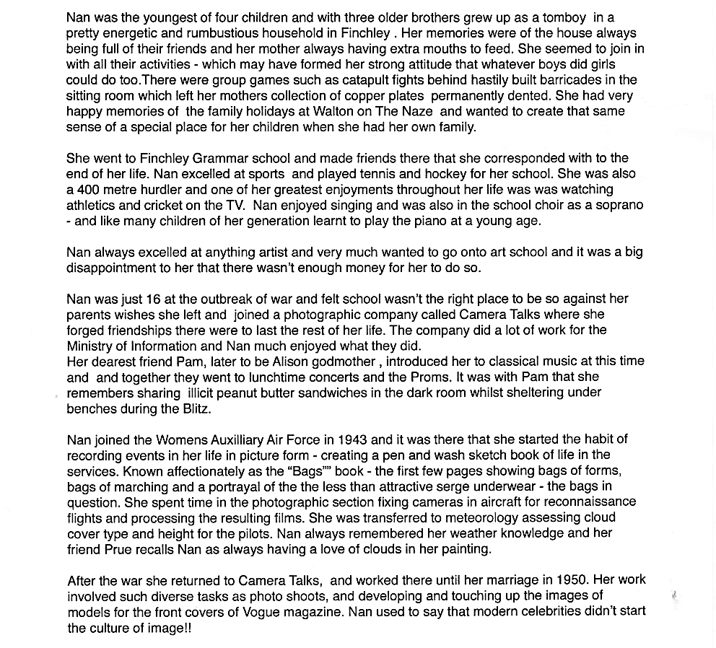
Interpretation is in the eyes of the beholder!
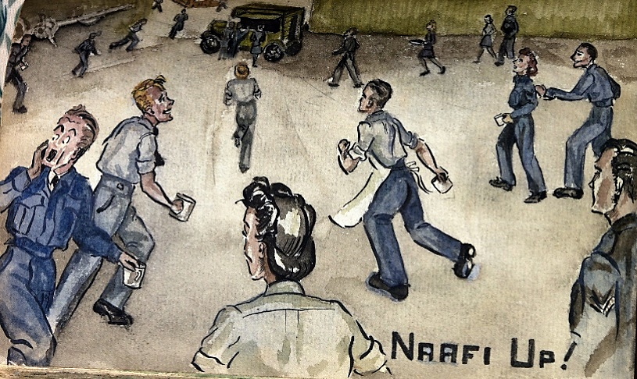
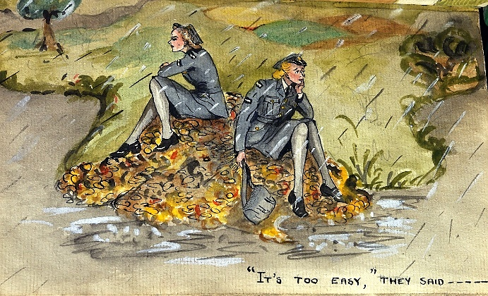
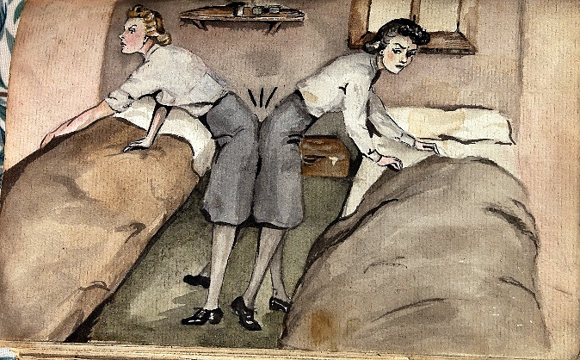
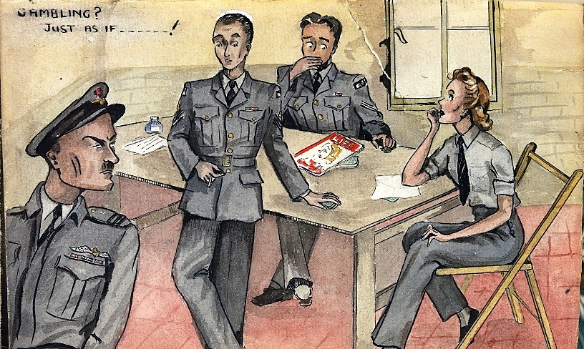
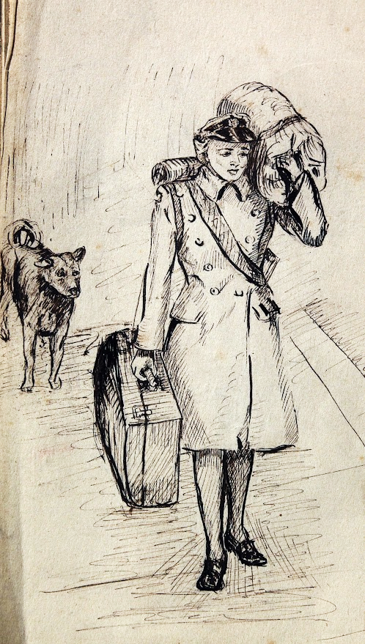
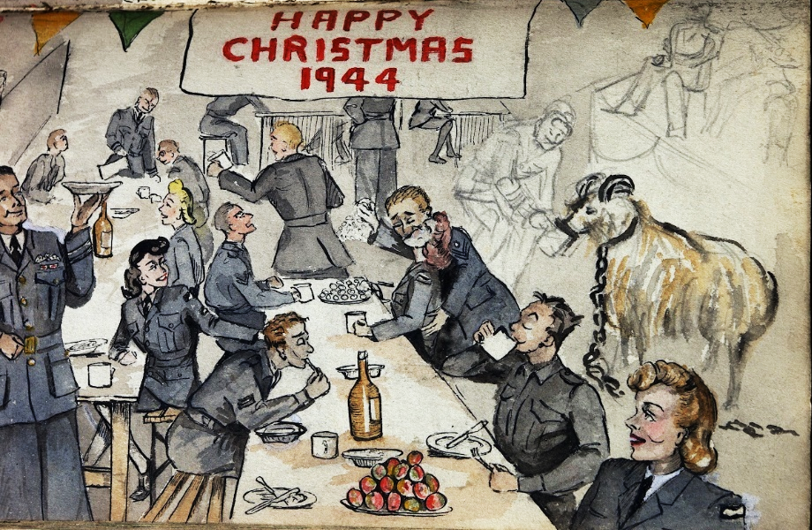

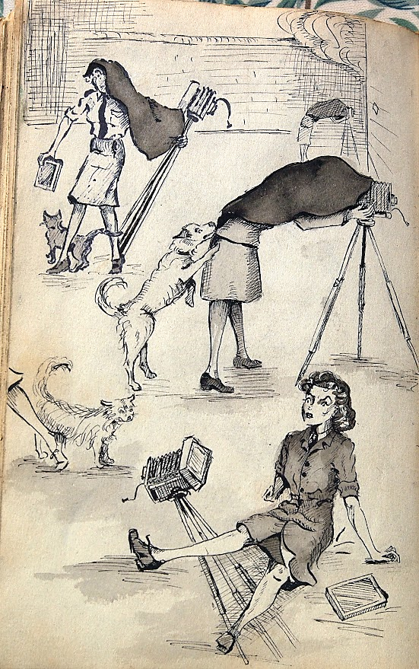
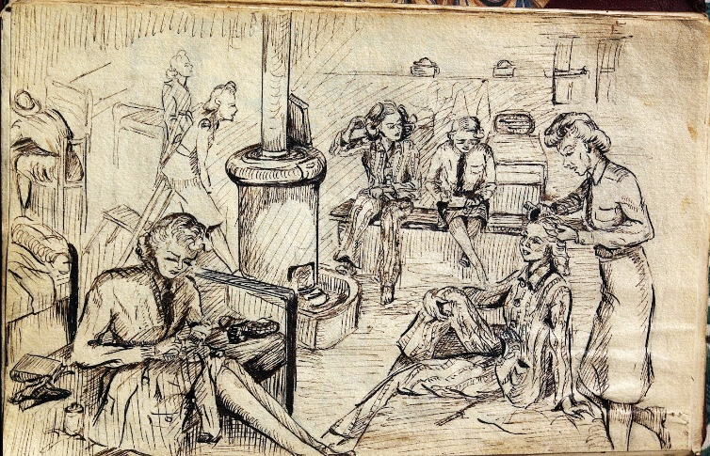
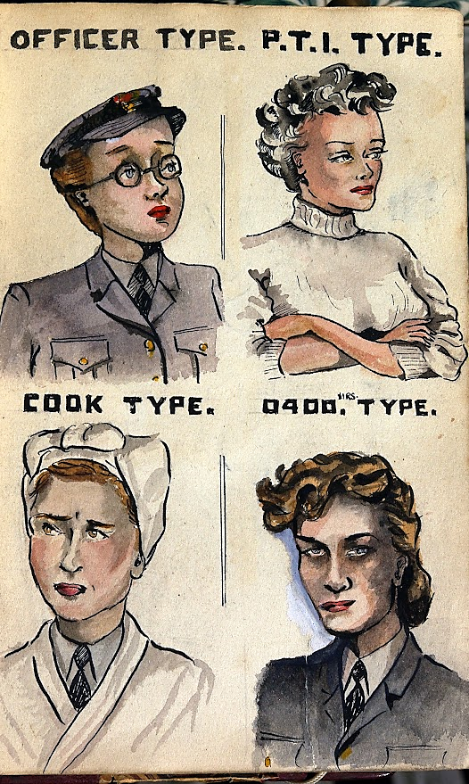
PTI = physical training instructor
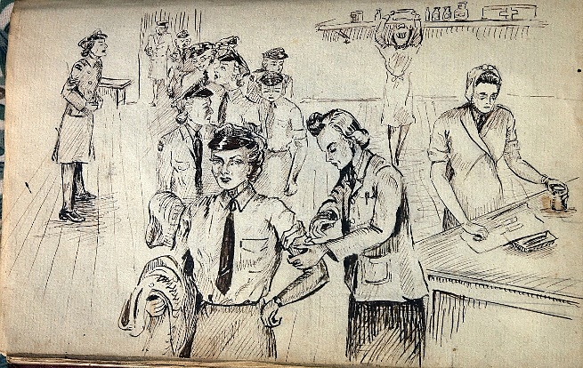
0400 sirs = keen type who is ready to go on duty at 4 in the morning??

Pat Davidson, Honeywood House
Memories of VE Day
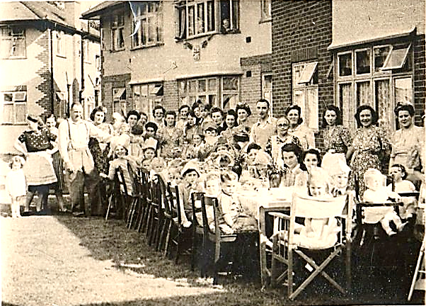
The photo (below) of our Close's VE Day street party brings back so many things. In the picture I'm seated near the back, turning and leaning this way, my right arm outstretched over the back of the chair, looking towards the photographer, no doubt trying to catch his eye so I'd be sure to get into the picture. My mum's standing just behind me, holding up my baby brother Christopher to include him too. I was exultant. The past twelve months had been really grim on the home front but we'd won through in the end!
How we'd hated Hitler's flying bombs. Whenever I'd heard that ticking engine cut out in the sky above, I'd gabbled fearful promises to God to be good in those silent seconds before the inevitable explosion. One of the last, in early 1945, blew out all our windows and cracked a wall but that was all.
And there'd been a dark period during 1944 when Mum {who was then expecting Chris) didn't know whether my soldier Dad would ever get back to us from the battlefields of Europe.
But now there was so much to be thankful for, to celebrate! Hitler's terror campaign had failed and Germany had admitted defeat. And Dad had survived and in due course would be coming back to England safe and sound. As victory in Asia was yet to come, 8th May 1945 was designated Victory in Europe Day.
The party ended just before three o clock and we crowded round a wireless to hear Winston Churchill. He said there was still much to do but "today we must allow ourselves a brief period of rejoicing". Jenny {who lived opposite in the Close} cheered and took me to one side. Being streetwise, independent ten year olds somewhat beyond our years, we decided to make for the centre of London straight away and join the crowds celebrating outside Buckingham Palace! It was only 30 minutes by tube and all public transport was FREE today. That was a big temptation and it was the deciding factor.

We hurried the half mile to Edgware Station, carrying tiny flags which Mum had made for us by tying Union Jack hankies to little sticks. We were ready to greet King George and Winston Churchill should they appear. I remember the thrill of boarding the busy tube train, a bona fide independent passenger for the first time in my life.
We'd sneaked joy rides on the tube in the past but only as far as the first deep station {Hampstead I think it was} to gaze at people who used it as an Air Raid shelter, some ladies still in dressing gowns and curlers handing us sweets.
Today life was so different, everyone friendly and cheerful even having a sing song before going into the tunnels. There was a lovely old couple opposite who insisted on giving us some of their precious chocolate ration when I told them my Dad was in the army, still far away. It was an amazing journey.
When we got to our destination the train emptied, all us passengers streamed out, crossing the Strand and then into Trafalgar Square. There was a huge roaring coming from the Mall. WE WANT THE KING...! WE WANT THE KING! But instead of heading that way, most of our travelling companions were turning off towards some celebrations in Piccadilly. The nice old couple stuck with us. They explained there'd been warnings issued to avoid the crowds around Buckingham Palace - because with the royal family now making appearances on the balcony, nobody was leaving but more and more people were piling in way up the Mall! It would be impossible for latecomers to get close enough to see anything.
If full grown people, not pint-sized ten year olds like us, had given up , what hope was there for us? Our new friends from the train took us through Admiralty Arch to check. All I could see were thousands of backs. From here I couldn't even see the Palace itself. It was such a letdown. I wanted to cry and suddenly the sight of a passing soldier in khaki looking like Dad was too much. According to Jenny I embarrassed her by howling out his name and crying my eyes out.
From there, memory blanks out. And then as though in a dream I found myself high on some khaki-clad shoulders, edging through the crowd towards the palace, using my little union jack to wipe the tears away. Apparently Jenny was right behind me, thanks to another of those darling soldiers on crowd duty.
By the time the royals came out, we were still far from the palace gates but now near enough to see them, lining up on the famous balcony. The King and Queen and Winnie himself. And the two teenage princesses!! Elizabeth, our future queen, was wearing her ATS uniform, knaki of course. As the royals waved, waved and waved again we just kept on cheering. The noise was deafening. It was beyond thrilling.
The old couple must have fixed it before heading off for an intended meet up with friends in Piccadilly. Thank goodness we met them and thank goodness for those kind soldiers, who packed us off to go home after that. Mum had saved me some biscuits from our street party, which I'm proud to say I'd helped to make that morning? They were delicious.

