Dutch Courage
The story of Cees Waardenburg
With four Appendices
I am indebted to Wim van Kamperdijk, from Holland, for bringing this story to my attention, providing lots of information and a photograph of the military funeral in Rudgwick churchyard.
There are three heroes of this 1944 story; only one of them survived the war. Two were killed on 30 August 1944 at Shackleford Heath, near Peper Harow, Godalming (see map in the Appendix) All three have close connections to Rudgwick in that year, the year of D-Day, V1 flying bombs (doodlebugs), and RAF bomber squadrons based at Dunsfold Aerodrome. It was also a year which began badly when the pilots and six crew of two Mitchell bombers of 98 and 180 Squadrons, RAF Volunteer Reserve (RAFVR), lost their lives at Pallinghurst on 7 January.
They had replaced 400, 414 and 430 Sqns, RCAF, the Canadians having been there since the drome was built by their engineers in May-October 1942. But that, and the January incident, are not part of this story. However, these RAF squadrons (specifically 180 Sqn) are part of the story, the planes are the same, B25 twin-engine Mitchell bombers, built by North American, a US company, and their missions were similar, including to bomb the German V1 bases.
The men in this story are:
- Wing Commander (Flying) Lewis Alan LYNN, D.S.O. and bar, D.F.C., VL.KR,
Commanding Officer, 139 Wing, RAF, Second Tactical Air Force, Dunsfold, aged 28;
- Reserve 1e Luitenant (Ft Lt) Cornelis (Cees) WAARDENBURG, D.F.C., B.L., B.K., VL.K., navigator/observer/bomb aimer to W/Cdr Lynn and trained pilot, 320 Squadron (Royal Dutch Naval Air Service), RAF, transferred to 180 Sqn just before the accident, aged 23;
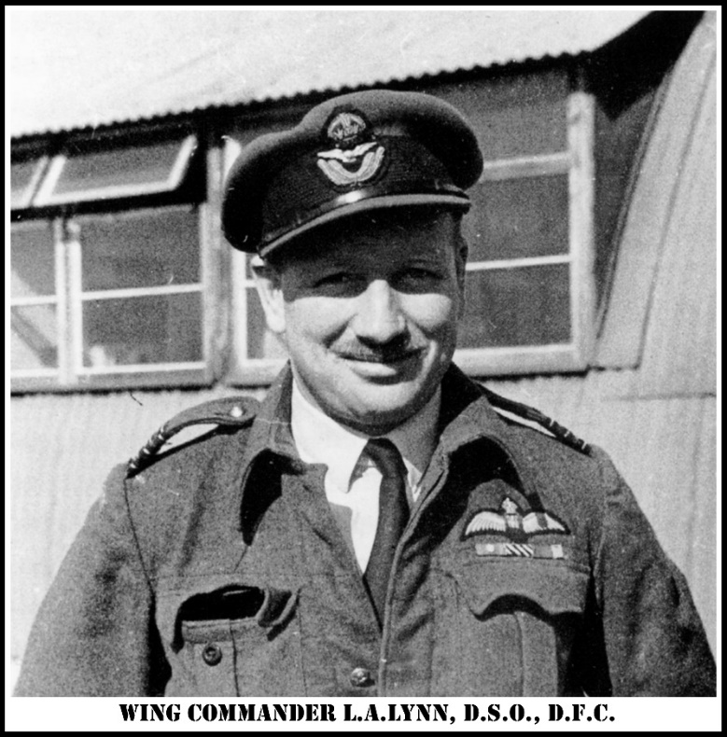
- Flying Officer Henry (Harry) George PAYNE, Air Gunner, 180 Squadron, RAF, also new to the squadron, aged 27.
‘Alan’ Lynn was a Springbok pilot from Witbank, Transvaal, South Africa. He was however born in 1916 in Barnes, Surrey. His parents, Frank Lewis Lynn and Evelyn May Lynn (née Alan), emigrated to South Africa. He married Beatrice Elizabeth Sharman (née Green) in Abingdon, Oxfordshire in 1938. Beatrice and Alan had a baby, Carol in 1942 in Hunstanton, Norfolk.
In Transvaal, Alan had initially attended the South African Training Ship (SATS) "General Botha" from 1932 - 1933. He then came to England to join the RAF, passing out as a Pilot Officer 12 July 1938. Promoted Flying Officer October 1940, Flight Lieutenant October 1941, Squadron leader May 1942, commanding 107 Sqn, in early 1944 he was commanding 320 (Netherlands) Sqn at RAF Lasham near Alton. Here he also came to know Cees Waardenburg. It is thought he took command of the wing at Dunsfold about the end of April 1944, under the airfield command of Gp Capt Clarence Dunlap. The Dutch squadron had also moved to Dunsfold to join 98 and 180 Sqns on 18 February 1944. The airfield was very crowded as a result, decent accommodation in very short supply. Lynn had become one of the RAFs most experienced pilots, and an expert in precision bombing techniques. It is believed he rented a house in Rudgwick whilst serving at Dunsfold. In Autumn 1944, he and 139 Wing left Dunsfold for the continent, believed to be to Melsbroek, Belgium (replaced at Dunsfold by 83 Group operating fighter aircraft). By then he had flown over 100 bombing sorties, exceptional for a Wing Commander. He later returned to South Africa where he was living at the time of his death.
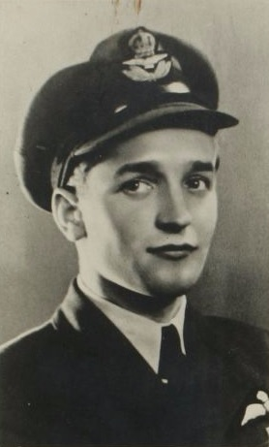
‘Cees’ Waardenburg was from Schipluiden, Holland. He had a brother Leen who had Cees’s pictures, a hipflask, newspaper articles from the early forties, a silver pin that forms the letter W of Queen Wilhelmina and his RAF ‘wings’ from his tunic. Leen said there were three years of his brother’s life with no contact, only the letters which came after his death. ‘Cees’ can be spelt ‘Kees’ and is pronounced as ‘Case’. Here I will use the spelling in most English usage.
It is believed Cees (left) was the eldest of his siblings. He had previously served, aged only 19, as a Reserve 2e Luitenant of Infantry Weapons in the Dutch army which fought the German invasion in 1940, alongside Wim Kamperdijk’s father (hence the connection), on the Grebbeberg, the scene of fierce fighting. He was awarded the Bronze Cross (B.K.) soon after this, on 6 November 1941, and posthumously awarded the Bronze Lion (B.L.) by a grateful Netherlands on 24 August 1946.
The citation reads: “He has distinguished himself by particularly courageous and tactful actions in combat against the enemy; in particular on May 12th, 1940 in combat against outposts near Stoutenberg, north of Hamersveld when he, in his capacity as leader of a patrol, was the first to enter a farm building in the area directly in front and clearing the building of enemies, which inspired his platoon to advance fearlessly; as well as repeatedly moving well ahead to reconnoitre.”
Cees was able to go home after Holland’s capitulation. His real love was to fly. He made
three attempts to cross to England, but the Dutch coast was a forbidden zone. At the third attempt he succeeded, on a small motor vessel owned and bravely sailed by Herman
Witkamp, with seven others, from Rozenburg, Zeeland, to Orford, Suffolk, landing on 4 September 1941. After initial flying school in England he was sent to De Winton, Canada for further training, returning in July 1943.
At first with 139 Sqn, he was then posted to the Dutch 320 squadron, which wore the distinctive uniform of the Dutch navy (RDNAS). He made over 100 flights from 3 October 1943 to just before his death. He had been navigator/observer/bomb aimer to Alan Lynn at RAF Lasham. He was then rested, before a transfer to 180 Sqn at Dunsfold, where he continued to be navigator for Lynn (they flew with all three squadrons). On 18 May 1944, he was awarded the Distinguished Flying Cross (see Appendix for citations), and on 13 July the Dutch Airman’s Cross (V.K.). the citation reads: “As captain of aircraft in 320 Squadron R.D.N.A.S. of Our Naval Air Service based in the United Kingdom, he has displayed courage, drive, skill and perseverance in numerous operational sorties over a period of eight months, as well by day as by night, having carried out numerous successful bombing attacks on hostile shipping, often in the face of heavy enemy flak whilst having had to repulse numerous attacks by enemy fighter aircraft.” [Note: “captain of aircraft” refers to his rank in the original Dutch, not that he piloted the plane.] At this time, he had not yet flown a Mitchell, but as a trained pilot, he now expected to fly his own plane, having completed 54 sorties, over 100 hours (98 as observer, three as pilot), which qualified him to be a pilot, had he lived.
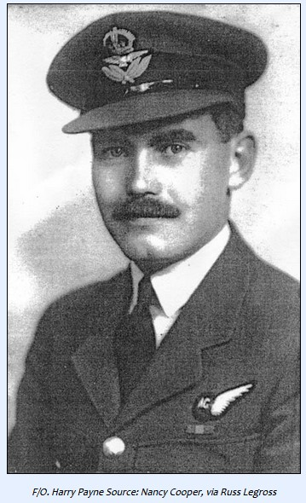
‘Harry’ Payne was the son of Henry Walter Cossington Payne and Nancy Lilian Payne of Dundee, Scotland. He was born, however, in Great Ilford Essex in April 1917. He joined the RAF, still in his teens, in 1935. He served in Palestine and Iraq, then in Egypt and Greece flying photo reconnaissance over the desert and over the retreat from Greece. He then had a spell as an air gunner instructor, followed by service in a glider squadron preparing for D Day. He also took part in dropping missions behind the lines to the French Maquis, and bombing bridges ahead of the advance into Normandy. He joined 180 Sqn at Dunsfold, like Cees Waardenburg, just prior to the accident.
Harry Payne married Nancy L Cooper in Rudgwick in July 1943. Harry was living with his wife and her parents at The High Croft in Rudgwick, located near the church. Nancy had a baby in Autumn 1944, named Gillian. Gillian never knew her father. Gillian married Paul Bellevue-de-Silva in Harrow in 1967. It is thought Lynn may also have lodged there with his wife and family.
The Events of Wednesday 30 August 1944
The scene is set. W/Cdr Alan Lynn is CO of 139 Tactical Wing at Dunsfold. He has also just completed his ‘tour’, and about to relinquish command. His erstwhile Dutch navigator/observer/bomb aimer, Cees Waardenburg, is now given permission to fly, and with no experience of Mitchell bombers asks to go up for a test flight. Harry Payne, rear gunner, also new to the unit (180 Sqn) agrees to go with him, Lynn agrees to the flight. There is, as far as can be gathered, no flight plan.

Waardenburg has been described as a popular and intelligent young man. Lynn had long promised him he could eventually captain his own plane. Lynn is described as having a ‘press-on’ character, a reputation for personally handling the lead plane in attacks on the continent successfully, and without having to go back for a second time. Waardenburg in his triple role gets much of the credit for this. They are a dream team, but not without some resentment from others, particularly the squadron commanders who feel undermined by their boss leading up to two attacks a day.

Keith Cudlipp, one of Lynn’s gunners, tells the story. “Cees, Johnny Pritchard and I were in our tent between the control tower and the Ops room. With us was Harry Payne who had just been posted to the wing as an air gunner and didn’t yet have a crew. In the meantime, Alan Lynn had told him to come along with us until he was sorted out.

That day, Cees and Harry had bowled into the tent to find Johnny and I listening to the radio, a short play called, I think, ‘Beetle Doctor’ which was quite interesting. Alan Lynn walked in and asked Cees if he would take our aircraft (FW268) up for an air test and Cees jumped up, looked at us and said ‘OK, any of you coming?’ Harry Payne, who hadn’t yet flown much on Mitchells, showed his willingness to go, but Johnny and I decided to stay, in order to listed to the end of the play. They were only going round the houses, so off they went.

I think it was about 20 minutes later when someone ran out of the control tower and shouted that a plane had gone down near Godalming. There were only two aircraft up that afternoon, and a few minutes later the other one landed, so we realised then it was Cees who had come to grief. I think that finished us for quite a while, as we were a very close crew. Even Alan Lynn said he wasn’t interested in doing any more operations.” [Surrey’s Most Secret Airfield, Paul McCue].

It emerged later Cees had been a little too exuberant, flying low over Peper Harow House, where land girls were working on the estate. An eye witness stated that the plane had roared up over the trees, come round for a second pass, and clipped a tree top, whereupon the plane flipped over and spun into the ground by a Canadian army vehicle park on Shackleford Heath, caught fire and killed the men instantly (see Appendix for map and photographs).

On 2 September, the two men were interred in Rudgwick churchyard, a break from the norm, which would have been to either take them to Brookwood Cemetery, or send the bodies back to the next of kin. But Harry was more or less a Rudgwick man by this time. Lynn wanted them buried close to where he and his wife lived, and where Harry also lived with his heavily pregnant wife and her family (High Croft).
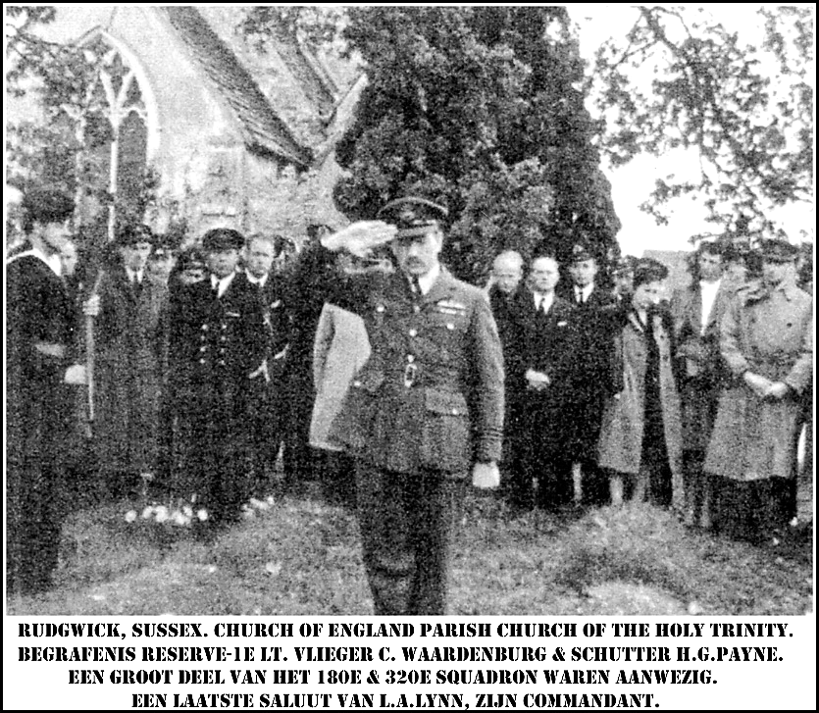

The “In Memoriam” below is from Rudgwick Parish Magazine

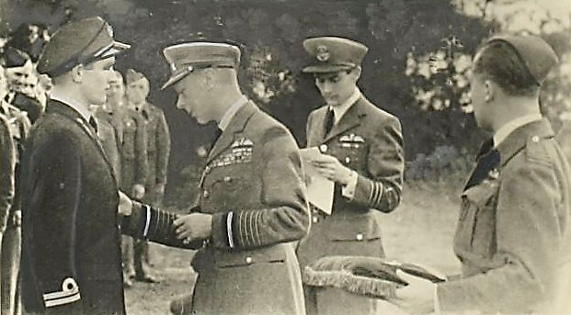
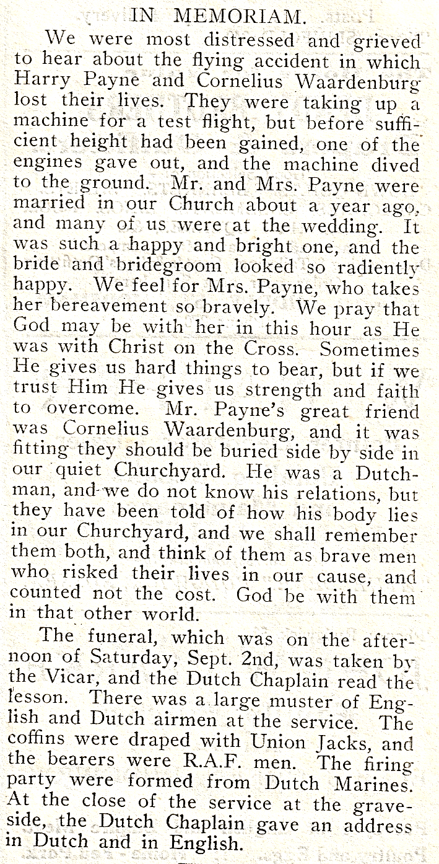
No evidence has been found for Cees’s lodgings. Another source suggested Lynn felt a huge responsibly for what had happened and wanted to retain some ownership and dignity. The Dutch newspaper photograph (undated, above) shows the graves are northeast of the church, where Payne’s CWGC headstone can still be found. There are civilians, and Dutch naval uniforms, among the assembled mourners. The lady on the right is joined by another mostly hidden behind Lynn, perhaps Dorothy and Nancy Cooper. After his death, probate was granted to Peter Waardenburg (his father or his youngest brother). Cees’s address was given as Dorpstraat, Schipluiden, a few kilometres northwest of Rotterdam, the village where he was born 12 September 1920. He is remembered today on the war memorial in Schipluiden (see below).
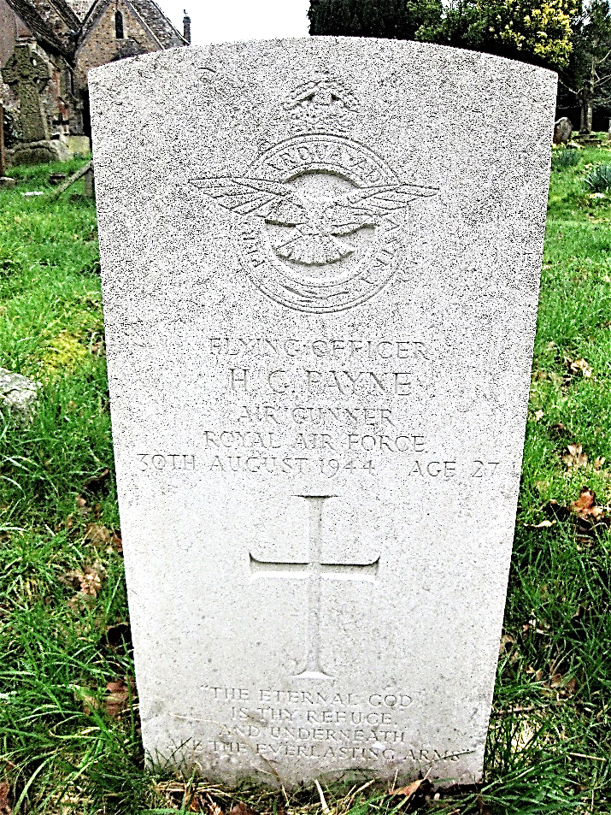
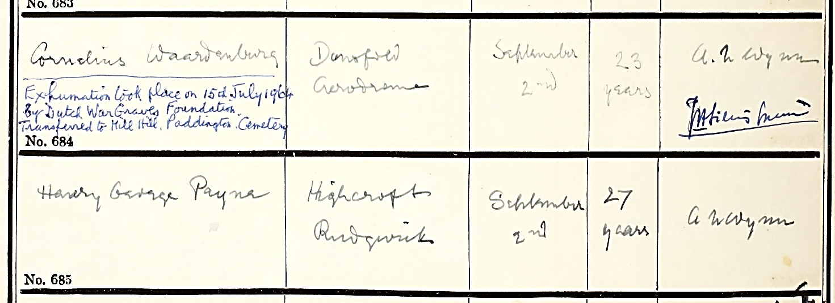
Cees’s remains were removed in 1964 to Mill Hill (Rudgwick death register below), but Harry’s are still in Rudgwick as testimony to the tragic events of 30 August 1944. As well as the DFC., awarded on 18 May, (left) presented to Cees by HM King Gorge VI at Dunsfold, Cees had also been awarded the Dutch Airmen’s Cross on 13 July, the citation referring to his courage, skill, perseverance, and devotion to duty. On the same day he, a foreign national, was granted permission by royal decree to wear his DFC medal He died seven weeks later, before what would have been his 24th birthday on 12 September.

The inscription at the foot of Henry George Payne’s Holy Trinity, Rudgwick, Commonwealth
War Graves headstone reads: “The Eternal God is thy Refuge and Underneath are the
Everlasting Arms”. His remains, unlike those of Cees, are in Rudgwick to this day.
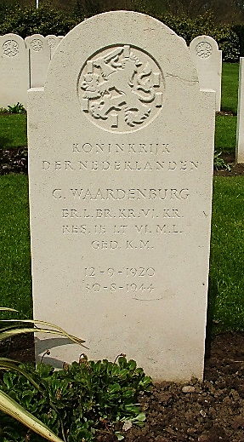

At Mill Hill Cemetery.
Koninkrijk der Nederelanden. C. Waardenburg
ER L. BR. VL.KR. [rank] RES. IE.LT. M.L. GED. K.M.
12-9-1920 30-8-1944
Wim van Kamperdijk wrote to me, “Leen Waardenburg did not expect his brother would die. Instead, he lived in the sacred belief that he could see again his brother after the war. In January 1945 he moved to Brabant from the Westland [ his home] which was already liberated, with the thought that he would meet his brother again. The message that Cees had been killed came to him like a sledgehammer. ‘That message I had to handle on my own after a journey that lasted four days,’ says Leen. ‘Back to the Westland I could not [go]. On the other side of the river was raging war still.’” This journey was extremely dangerous but achieved successfully. With help from Canadian troops, Leen reached Eindhoven, where he learned of his brother’s death. Leen said, “My brother was a good pilot. Many pilots wanted to fly with him, because if you had flown with Cees and Commander Lynn, you returned alive, a great opportunity again."
139 Wing, Attacks on Flying Bomb Bases
The RAF had spent much of late 1943 and 1944 relentlessly attacking the numerous bases for V1 Flying Bombs, even before they became operational. It was an attack on bases in the Cherbourg peninsula which led to the collision and crashes at Pallinghurst killing eight airmen in two Mitchells on 7 January 1944. Lynn’s wing was also involved in many other sorties. Cees’s D.F.C. citations, for example, refer to attacks on carriage and wagon shops.
“The V1 and V2 rocket attacks on England during 1944/1945 were debilitating to say the least, and were to do damage both mentally and physically, and so effective were they that the attacks on London became known as the “Second Blitz“. One of the many airmen involved in hunting down
and destroying the relevant rocket launching sites (known as “Operation Crossbow" and “Operation Noball”, November 1943 - May 1945) was Wing-Commander Lewis Alan Lynn.
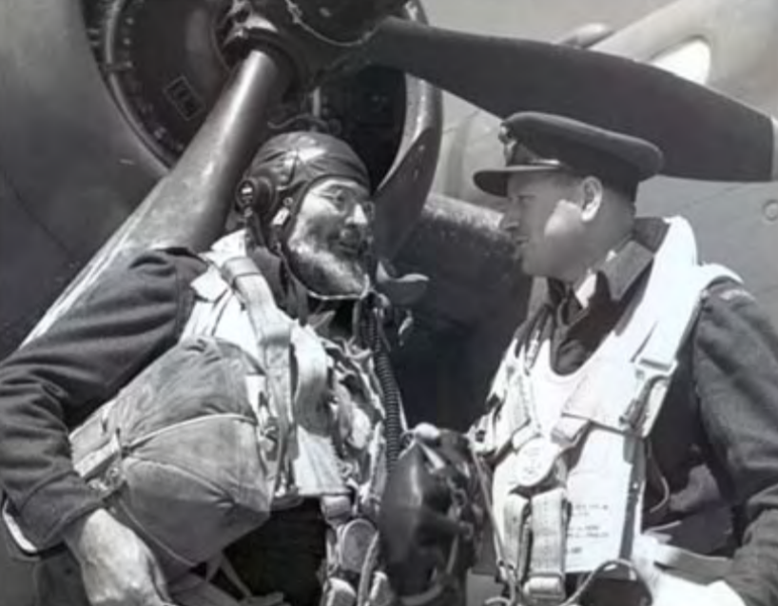
On 20 June 1944, Lynn and Waardenburg had an extra passenger on a Noball raid. He was Ernest Hemingway [left, with Lynn, [©IWM CL198] and he flew on a 180 Sqn mission against the site at Moyenneville in the Somme department. An indication of how personal these raids were to both the crew and the American author and journalist, Hemingway, is that a few days earlier, 15 June, a doodlebug had come down in Cranleigh. Hemingway, already in the area, had visited the site and taken some pieces of metal away. The police duly accosted him in the officer’s mess at Dunsfold and demanded them back!
“A well-known South African bomber pilot skilled in the art of precision bombing was out this
morning [no date provided] helping to smash the launching platforms [in Northern France] from which the Germans are sending their flying bombs across Southern England. He is Wing Commander L.A. Lynn, of Witbank, operating with a Mitchell bomber group of the Second Tactical Air Force [2nd TAF]. Described as one of the most experienced pilots in the group, Lynn led today’s assault by the RAF. and Dutch Mitchell bomber crews on the flying bomb installations; it was his 85th operational trip. [Lynn’s crew. Below. Waardenburg centre, Lynn to his left].
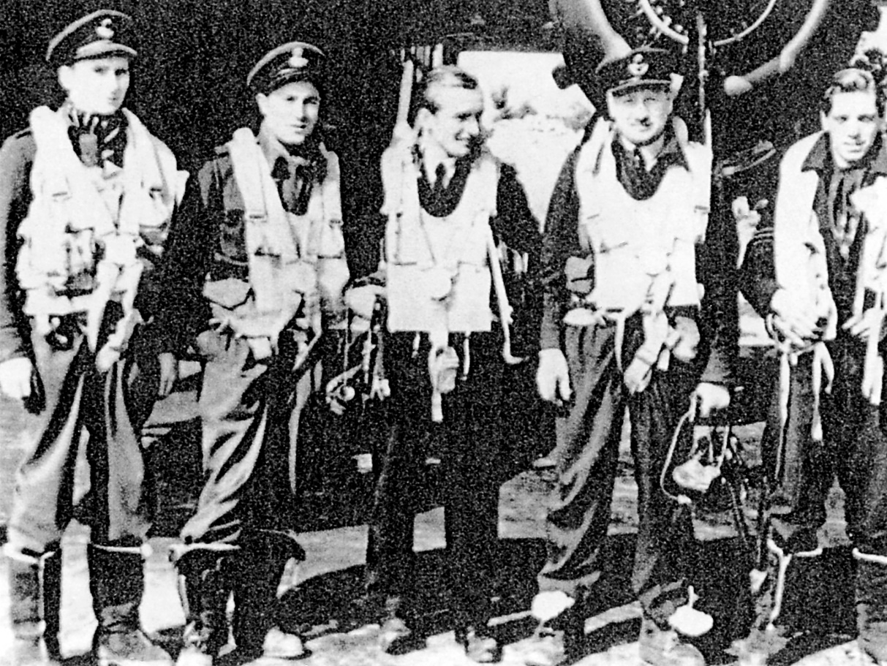
On his return he said: ‘Visibility was good, and our bombs fell in the target area all right.’ He and his group sought out skilfully camouflaged installations in the Pas de Calais area and the Mitchells hit their targets squarely despite accurate and persistent flak, some of which tailed the bombers out to the coast on their homeward trip. Flak was thick in the target areas, indicating the importance the enemy attaches to safeguarding the rocket sites. Another ‘secret weapon’ was used against our planes without effect. This consisted of a square box-like missile fired into the air to burst and scatter long strips of silvery and apparently metallic substance, possibly designed to foul the propellers, but it was completely ineffective.” [acknowledgement, https://peek-01.livejournal.com/103356.html]
Roger Nash

Appendices
- Wing Commander Lynn, DFC, DSO & bar, VL. KR. Citations
26 June 1942, Distinguished Flying Cross
“This officer led almost every raid carried out by his squadron recently. These include low-level attacks on the enemy's shipping, docks, marshalling yards and other important targets. In August 1941, he led a formation in an attack on a large convoy and sank a 5,000-ton ship. He has proved himself to be an inspiring leader in the air, while on the ground, his initiative and energy have been instrumental in raising the squadron to a high pitch of operational efficiency."

11 February 1944, Distinguished Service Order
“This officer has completed a very large number of sorties and has displayed skill, courage and determination of the highest order. He is a most inspiring and forceful leader, whose personal example has been reflected in the fine fighting qualities of his squadron which has obtained many successes in recent operations over Northern France. Wing Commander Lynn has displayed outstanding keenness and devotion to duty and his achievements have been worthy of great praise.”

14 July 1944, Distinguished Service Order (bar)
“Wing Commander Lynn has completed a large number of day and night sorties during which he has successfully attacked a wide range of strongly defended targets. He has maintained a high standard of operational flying and his genius for leadership has been outstanding. His achievements have won great praise”.

16 November 1944, Vliegerkruis
“As tactical commander of 320 Squadron R.D.N.A.S. of Our Naval Air Service in the United Kingdom, he has commanded this squadron in remarkable fashion over a period of four months so said part of Our Naval Service could highly benefit from his knowledge and wartime experiences.”

- Cornelis Waardenburg, Recommendations for Distinguished Flying Cross

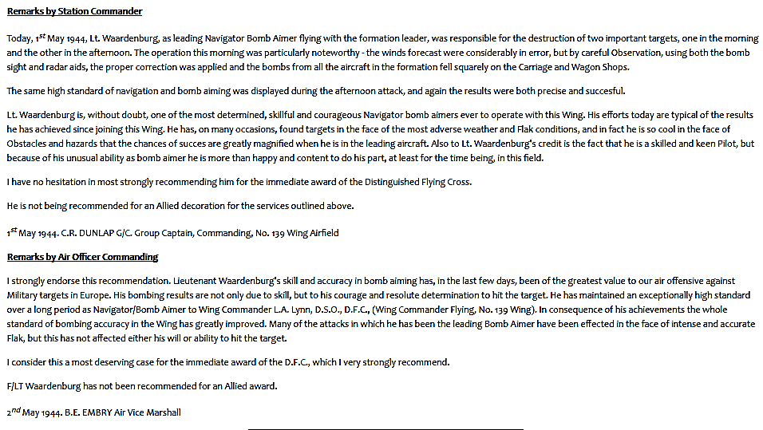

- The Crash Site
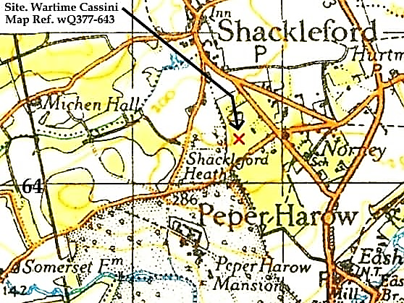

Police report
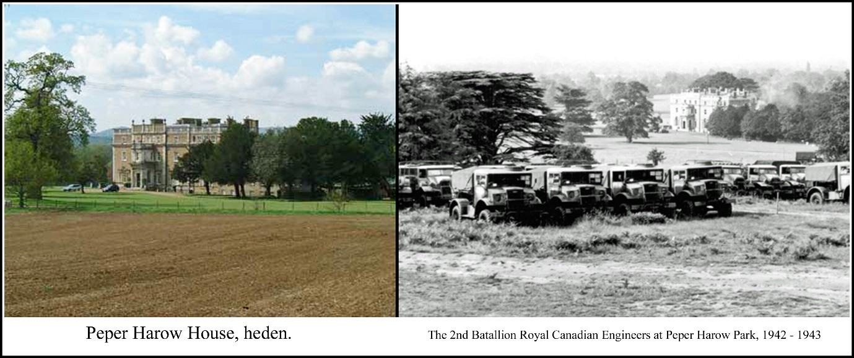
“At 16:45/30, British Mitchell Bomber, No. FW 268, Squadron letters EVO crashed at Canadian Vehicle Park, Shackleford Heath, Parish of Peper Harow, M.R.377-643. Machine wrecked and burnt out. Two in crew, both killed: – Pilot Lt. WAARDENBURG R.D.N.A.S, passenger F/O HENRY GEORGE PAYNE, RAF, both of 139 Wing, Dunsfold Airfield. Plane from Dunsfold Airfield on an air test. Guard mounted at 17:30 hours by HQ No.1 CCOD (Canadian Army Ordnance) Peper Harow Park, 1 NCO and 10 men. NFS (National Fire Service) in attendance. RAF Dunsfold, and 49 MU, Faygate, informed. Damage sustained to Canadian Army equipment.”
Further information, with links to both the other 1944 crashes https://dunsfoldairfield.org/crash-at-shackleford-heath-mitchell-30th-aug-1944.
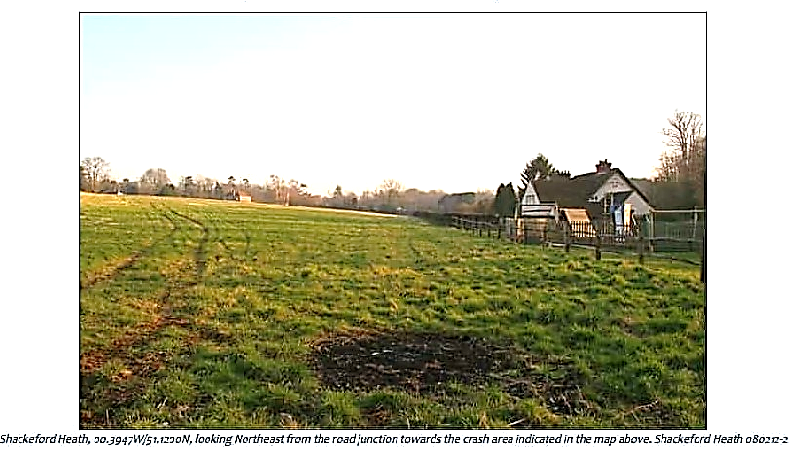
The satellite image (© Google Earth, below) supplied by Wim van Kamperdijk, marks the position he believes the plane crashed, a few metres further north than in the map above. There is more tree cover than there was in 1944.
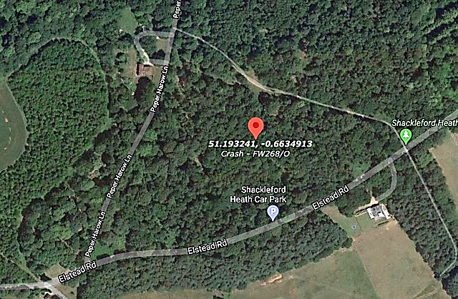

As well as the 7 January 1944 event over Rudgwick, killing eight men in two Mitchells, and the crash at Shackleford on 30 September 1944, a third Mitchell crash of FW264, 180 Sqn occurred on 6 October 1944 just north of Blacknest Farm, close to Dunsfold Common. The plane was one of 12 heading to a raid on a fuel dump in Holland. As with the January crashes, this was a collision, this time after take-off in cloud. three bombs aboard exploded (warning: two never found). The other plane safely returned to Dunsfold. The crew of four in FW264 were all killed.
The bad luck at Dunsfold extended to Horsham on 7 June 1944 . I found this in a National Fire Service report, uncannily similar circumstances to the one at Pallinghurst on 7 January, and in nationality, moreover, both crews of four airmen were Dutch, possibly known to Cees Waardenburg.

Double plane crash at Kay’s Lane (Denne Park) and Kerves Lane, Horsham. Eight Dutch airmen killed. The two planes had taken off from Dunsfold Aerodrome, loaded with leaflets, which were to be dropped over France. The two planes collided above Horsham, crashing in and near Denne Park. It was a dark night. One plane was burning on the hill. As the NFS got the pumps into position it exploded, dispersing parts of the plane, bodies and limbs of the crew, and thousands of leaflets, all over the hillside. The second plane had crashed at Kerves Lane, But wasn’t visible; the Fire Crew spread out in the darkness to find it. The reason it could not be seen was because it lay in a very deep crater. As the men approached, an unexploded bomb on board went off; all the men had a very lucky escape. Because of the depth of the crater, the force of the blast went upwards.

This brought the number of Dunsfold deaths in southern England 1944 to 22.
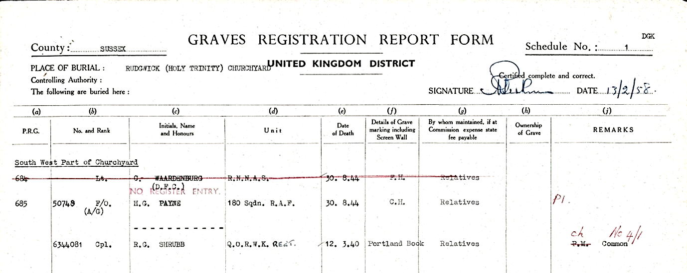
- The Burial Site
Holy Trinity, Rudgwick
The third name, Cpl Raymond Shrubb is an unconnected death in Rudgwick. He died, when on leave from his regiment, at home in 1940. This (© CWGC) document adds to the evidence of the death register (above) of the original interment of Cornelis Waardenburg in Rudgwick churchyard. These three are the only Second World War CWGC headstones in Rudgwick.

Schipluiden War Memorial
C Waardenburg is named on the sandstone Oorlogsmonument (war memorial), above and
below: on the right, last name, one of 14 men of Schipluiden killed in the 2nd World War [acknowledgement, Creative Commons Attribution-Share Alike 3.0 Netherlands license]. Note the years read 1940 - 1945.
